BLOOM SKIN



## DR. RADHAKRISHNAN GIRLS COLLEGE MAHARAJA GANGA SINGH UNIVERSITY (BIKANER)

In Partial fulfillment of the requirement for **Bachelor of Computer Application**

(BCA part 3rd ) year of submission (2021-22)

### SUBMITTED TO: SUBMITTED BY:

Dr. Minal Kochar **Chahat Verma**

### (H.O.D)Department of computer science Mskan Riya

**Simran Kour Simran Moyal**

# Preface

This project works is extended to those who are intrested in PHP. This project work includes"BLOOM SKIN".

The main project name is "BLOOM SKIN" in which I explain that how this website is helpful for users.Through this website people can findout few tips and tricks related to their skin issues from which they can enhance their beauty.

# ACKNOWLEDGEMENT

We would like to express our special thanks of gratitude to my professor***“Dr.Minal Kochar”,”Mr.Debashish Sinha”,”Miss. Monika Sachdeva”***and***”Mrs.Monika Goyal”.***who gave us the golden opportunity to deal with this wonderful project ,who also helped us in completion of project came to know about So many ner things we are really thankful to them.Secondly we would also like to thank our parents and friends who helped us a lot in finalizing this project within the limited time frame.

And at the end we thank our principal sir and our institute for their support. We also thank our family and well wisher for their encouragement and corporation.

Last but not least ,we are thankful each and everyone who is directly or indirectly related to our project help us in achieving in our goal.

Chahat Verma Muskan

Riya

Simran Kour Simran Moyal

# CERTIFICATE

This is to certify that this project has been made by ***Chahat Verma, Muskan, Riya, Simran Moyal* and *Simran Kour***of Class **BCA part3rd** by using various tools and techniques based on PHP,MYSOL under my guidence and have been completely successfully.

### Date:

**Place: Sri Ganganagar (Raj.)**

**Submitted to:** Dr.Minal Kochar H.O.D(Computer department)

DR RADHA KRISHNAN GIRLS COLLEGE

SRI GANGANAGAR (RAJ.)

# Contents

* Intoduction
* Data flow Diagram
* ER diagram
* System Requirement
  + Software requirement
  + Hardware requirement
* Project Platform
* Case Study
* Screenshots
  + - * + Reference Login Page
        + Reference Login Page connectivity
        + Home Page
        + About Us
        + Contact Us
        + Contact Us Connectivity
        + Sign-Up
        + Sign-Up Connectivity
        + Creator
        + Creator’s Login
        + Creator’s Login Connectivity
        + Term and Conditions
        + User’s Login
        + User’s Login Connectivity
        + Solutions
        + Dark Circles
        + Tanning
        + Acne Scar
        + Dry Skin
        + Oily Skin
        + Pigmentation
        + Blemishes
        + Enlarged Pores
        + Uneven Skin Tone
        + Wrinkles
        + Anything Else
        + Anything Else Connectivity
* Source Code
* Conclusion
* Bibliography

# Introduction of BLOOM SKIN

The word 'BLOOM' refers *blossom sense* or we can say that *the flowering state the roses are in bloom.*And the term 'SKIN' refers to the body's outer covering,which protect against heat and light,injury and infection. Skin is made up three main layers: Epidermis , Dermis, and Hypodermis.

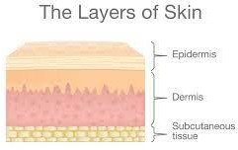

Elderly people use natural and ayurvedic herbs to enhance their natural beauty . As like they use gram flour as a facewash, Fuller's earth as a body soap and shampoo and so many home remedies they use to enhance their beauty.

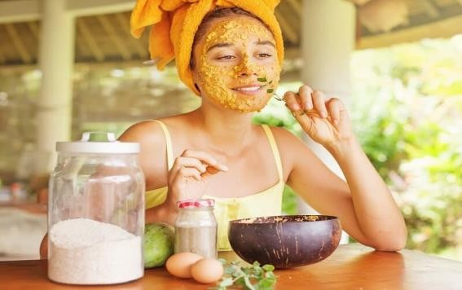

# Data Flow Diagram

A Data Flow Diagram (DFD) is a way of representing a flow of data of a process or a system (usually an information system). The DFD also provides information about the outputs and inputs of each entity and the process itself. A data-flow diagram has no control flow. There are no decisions rules and no loops. Specific operations based on the data can be represented by a flowchart.

enter

testing

Home page

of bloom skin

exit

report

enter

ID/ Password

response

know your

skin login page

Concern enter

check detail

Concern

report generated

concern response

detail entered

solution generated

Solution's

suggestion

replay

detail response

USER

View Suggestion

Solution's Suggestion

Suggestion

Concern

Know your skin

# E-R Diagram

HOME

ABOUT

US

BLOG

SOLUTION

PROBLEMS

IDENTITY

ARTICLES

VIDEOS

**USER**

An Entity-Relationship Diagram (ERD) is a data modeling technique that is graphically illustrates an information system's entities and the relationships between those entities.

An ERD is a conceptual and representation model of data used to represent the entity framework infrastructure

# SYSTEM REQUIREMENT

|  |  |
| --- | --- |
| Software Requirement | |
| Operating System | Window 7 |
| Project Platform | Wamp Server |
| Language | PHP, HTML |
| Database | SQL |

|  |  |
| --- | --- |
| Hardware Requirement | |
| Input Device | Keyboard , Mouse |
| Output Device | Monitor, Printer |
| Drive Devices | CD,ROM |
| Hard drive disk | 2GB or higher |
| Processor | Dual core |

**Project Platform**

In IT, a platform is any hardware or software used to host an application or service. An application platform, for example, consists of hardware, an operating system and coordinating programs that use the instruction set for a particular processor or microprocessor. In this case, the platform creates a foundation that ensures object code will execute successfully.

In our project “**BLOOM SKIN”** we have used following language HTML , CSS and PHP. These languages are platform independent. So this project can run on any platform such as:- Windows, Mac, and LINUX, and UNIX, etc.

## HTML:-

HTML(Hypertext Markup Language) is the standard markup language used to create web pages. HTML is written in the form of HTML element consisting of tags enclosed in angular brackets.

## CSS(Cascading Style sheet)

It is a style sheet language used for describing the look and formatting of a document written is a markup language. While most often used to style web pages and interfaces written in HTML and XHTML.

## My SQL:-

My SQL is developed, distributed and supported by Oracle Corporation. My SQL is a database system used on the web it runs on a server. My SQL is ideal for both small and large application.

## PHP:-

PHP( recursive acronym for PHP:- "Hypertext Pre Processor") is widely used to open source general purpose scripting language that is especially suited for web development and can be embedded into HTML.

# CASE STUDY

## Introduction

The word 'BLOOM' refers *blossom sense* or we can say that *the flowering state the roses are in bloom.* And the term 'SKIN' refers to the body's outer covering, which protect against heat and light, injury and infection. Skin is made up three main layers: Epidermis , Dermis, and Hypodermis.

Elderly people use natural and ayurvedic herbs to enhance their natural beauty . As like they use gram flour as a facewash, Fuller's earth as a body soap and shampoo and so many home remedies they use to enhance their beauty.

## Skin Issue

There are many types of skin issues and it forms due to many reasons ,And skin issues can be occur due to any allergy or it can also be occur due the changing weather and pollution. And skin problems can be hormonal too...

## ACNE

Few of the skin issues are mention below:--

Acne, the most common skin disorder in the U.S., can be a source of anxiety for every teen. Plus, the incidence of acne is growing in adults, too.

Acne is caused by blocked hair follicles and oil (sebaceous) glands of the skin, often triggered by hormonal changes. The term acne refers to not only pimples on the face, but blackheads, cysts, and nodules as well. Some people get acne on other parts of their body too, such as the back and chest.

## DARK CIRCLES

**Oversleeping**, extreme fatigue, or just staying up a few hours past your normal bedtime can cause dark circles to form under your eyes. Sleep deprivation can cause your skin to become dull and pale, allowing for dark tissues and blood vessels beneath your skin to show.

## TANNED FACE

**Oversleeping**, extreme fatigue, or just staying up a few hours past your normal bedtime can cause dark circles to form under your eyes. Sleep deprivation can cause your skin to become dull and pale, allowing for dark tissues and blood vessels beneath your skin to show.

## HYPERPIGMENTATION

Hyperpigmentation is a common, usually harmless condition in which **patches of skin become darker in color than** the normal surrounding skin. This darkening occurs when an excess of melanin, the brown pigment that produces normal skin color, forms deposits in the skin.

## BLACKHEAD/WHITEHEAD

What you're looking at may be a form of acne called whiteheads or blackheads. Whiteheads and blackheads consist of the same material, which is typically a combination of dead skin cells, oil, and sebum. However, **whiteheads are closed pores, while blackheads stay open**.

## UNEVEN

Uneven skin tone is an umbrella term that typically refers to **texture issues, blotchy skin, facial flushing, or hyperpigmentation**. Some people may refer to these conditions as pigmentation disorders.

## WRINKLES

Wrinkles, a natural part of aging, are most prominent on sun-**exposed** skin, such as the face, neck, hands and forearms. Although genetics mainly determine skin structure and texture, sun exposure is a major cause of wrinkles, especially for people with light skin. Pollutants and smoking also contribute to wrinkling.

## Causes of skin disorders

Skin Issues can be occur due to many reasons like weather, climate, hormonal changes, and so on there are many reasons from which any type of skin problem can occur.

Let's see how skin issues occurs and what are its causes . By few examples we can understand this very easily.

* Shamita is 19 year old girl. She is a college student and she has a lot of **dark circles** because she didn't slept on time and takes a lot of stress . And she has tried many of the eye creams but her dark circles are just same even by trying many eye creams her undereye area skin become too thin because of the chemicals which are present in the eye cream.
* Anita is 17 year old girl and she has many **acne** on her face because earlier she was ill and due to this illness she has taken many medicines and due to the reaction of those medicines she got many acne on her face.
* Soniya is a 25 year old girl . She is a tourister her work is of travelling .And due to sunny weather she has too much **tanning** on her face and she love to be presentable everywhere but due to tanning she felt bad due to his tanned skin. And because of this tanned face she looses her confidence of presenting herself.

## Treating skin disorders

There are several treatments are present for all type of skin issues . There is no issue is present of which treatment is not available .

The solution of few problems are shown below :--

### DARK CIRCLE

**The Best Routines for Getting Rid of Dark Circles and Under Eye Bags**

Cold Compress. In the morning or evening – or better yet, in the morning AND the evening – apply a cold compress for about 10 minutes. ..

Cucumbers

Cucumber Juice + Lemon Juice Rose Water

Tomatoes. Cold tea bags

* **TANNING**

Combine two tablespoons of the **Bengal gram flour with** a pinch of turmeric, some milk and one tablespoon of rose water. Apply this pack on the tanned skin leaving it for about 20 minutes and then wash your face with cold water. You can also gently massage your face by putting some water on the dried face pack.

* **ACNE**

**Easy and Proven Ways to Get Rid of Pimples Fast**

Keep your hands off your face!

Tread carefully when it comes to home "remedies." Apply a warm compress.

Use an acne spot treatment. Wash your face regularly.

Try a product with salicylic acid. Go light on your makeup.

Tweak your diet.

## Preventing skin disorders

Certain skin disorders aren’t preventable, including genetic conditions and some skin problems due to other illnesses. However, it’s possible to prevent some skin disorders. Follow these tips to prevent infectious skin disorders:

* Wash your hands with soap and warm water frequently.
* Avoid sharing eating utensils and drinking glasses with other people.
* Avoid direct contact with the skin of other people who have an infection.
* Clean things in public spaces, such as gym equipment, before using them.
* Don’t share personal items, such as blankets, hairbrushes, or swimsuits.
* Sleep for at least seven hours each night.
* Drink plenty of water.

Noninfectious skin disorders, such as acne and atopic dermatitis, are sometimes preventable. Prevention techniques vary depending on the condition. Here are some tips for preventing some noninfectious skin disorders:

* Wash your face with a gentle cleanser and water every day.
* Use moisturizer.
* Avoid environmental and dietary allergens.
* Avoid contact with harsh chemicals or other irritants.
* Sleep for at least seven hours each night.
* Drink plenty of water.
* Eat a healthy diet.
* Protect your skin from excessive cold, heat, and wind.

Learning about proper skin care and treatment for skin disorders can be very important for skin health. Some conditions require the attention of a doctor, while you can address others safely at home. You should learn about your symptoms or condition and talk with your doctor to determine the best treatment method

**Reference Login Page**

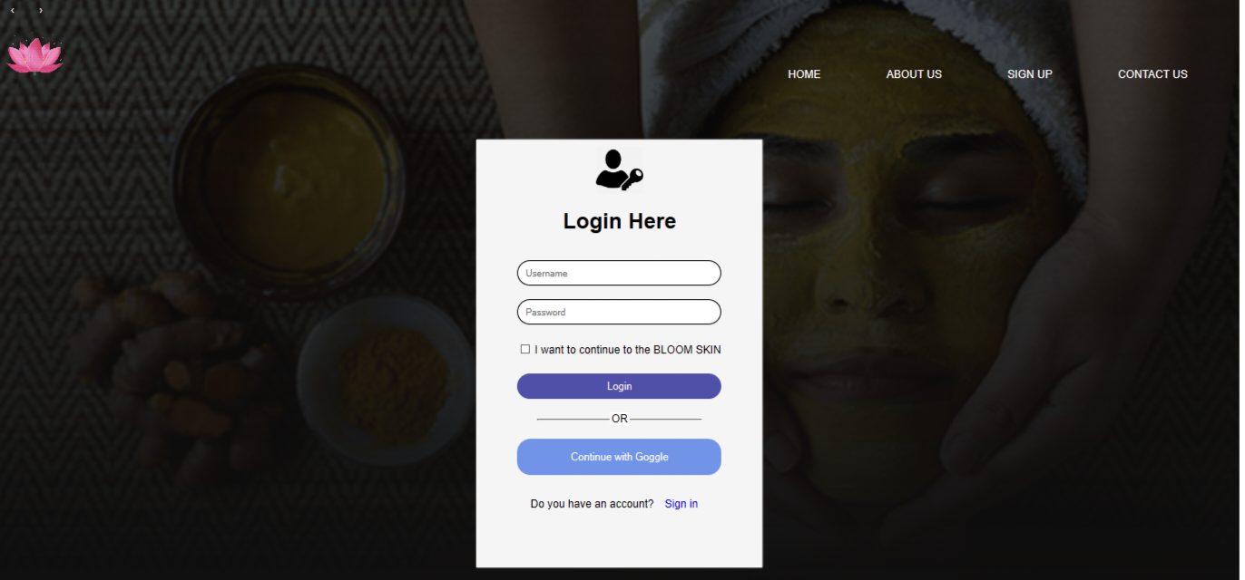

**Reference Login Connectivity**

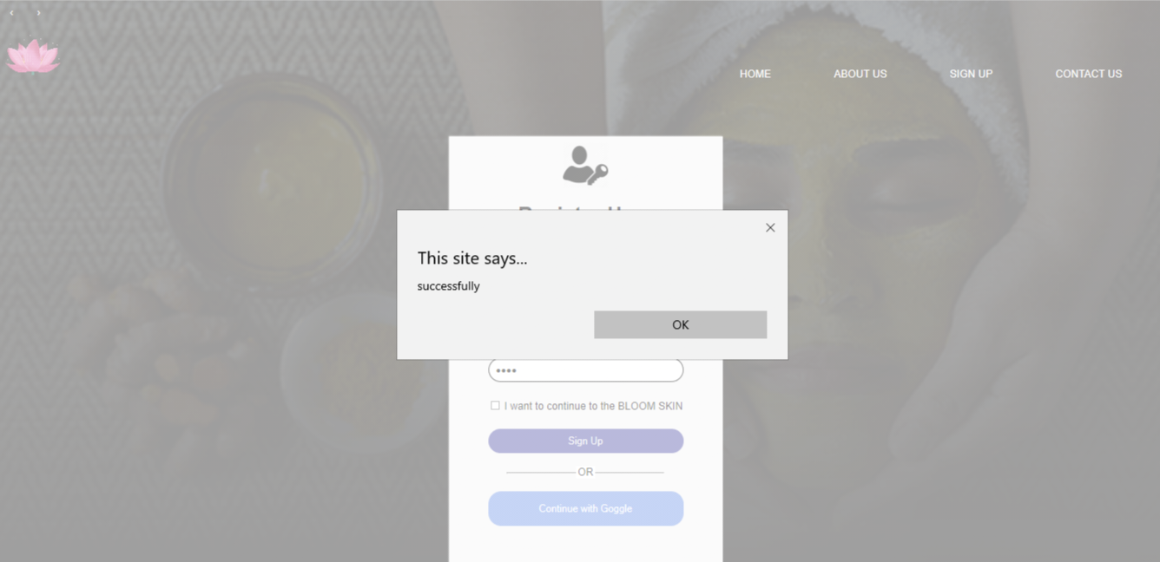

**Home page**

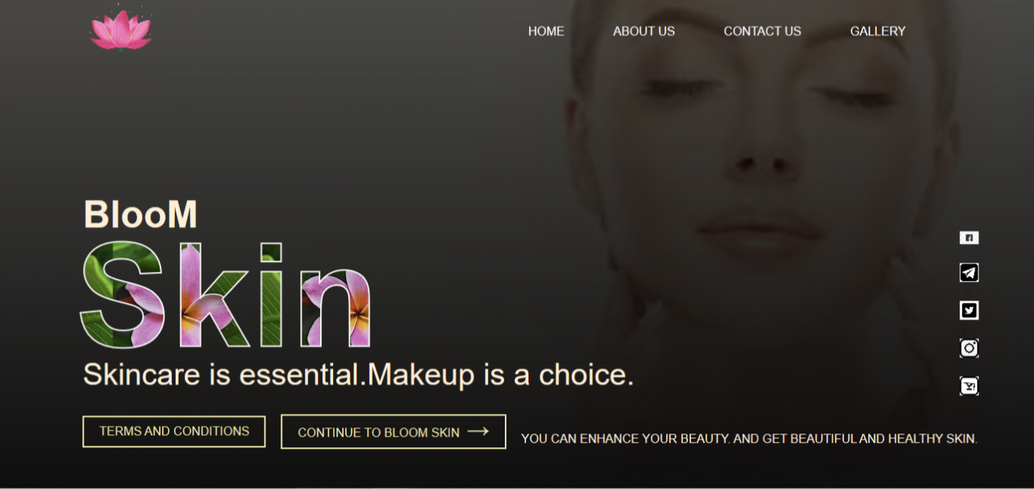

**About Us**

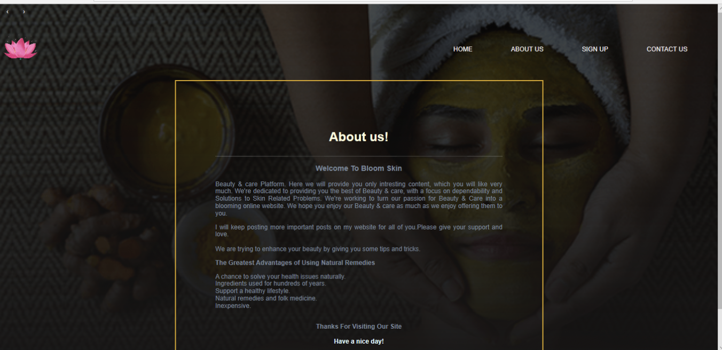

**Contact Us**

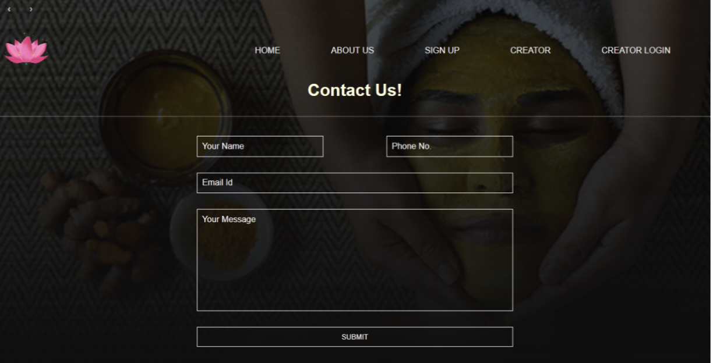

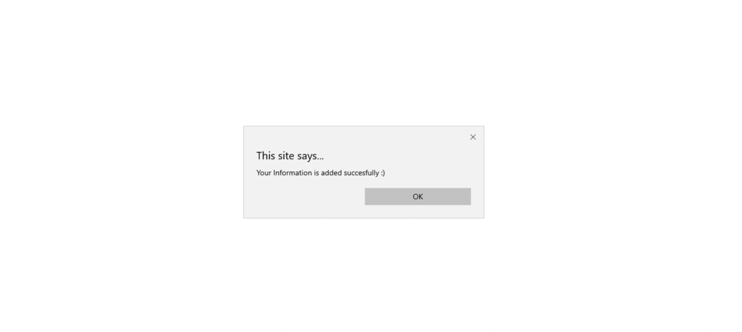**Contact Us Connectivity**

**Sign-Up**

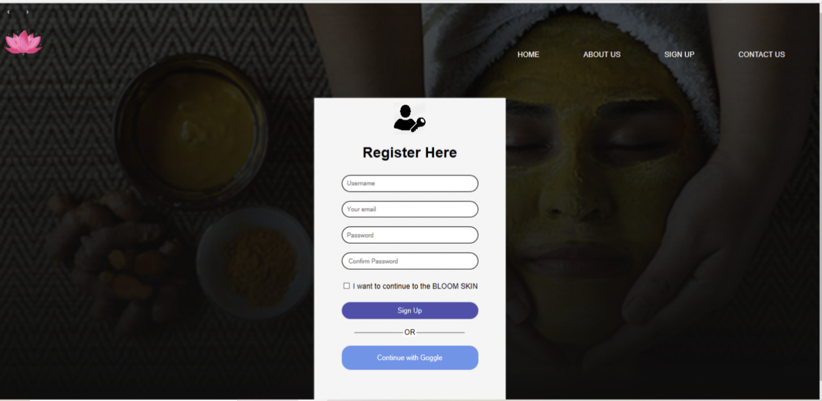

**Sign-Up Connectivity**

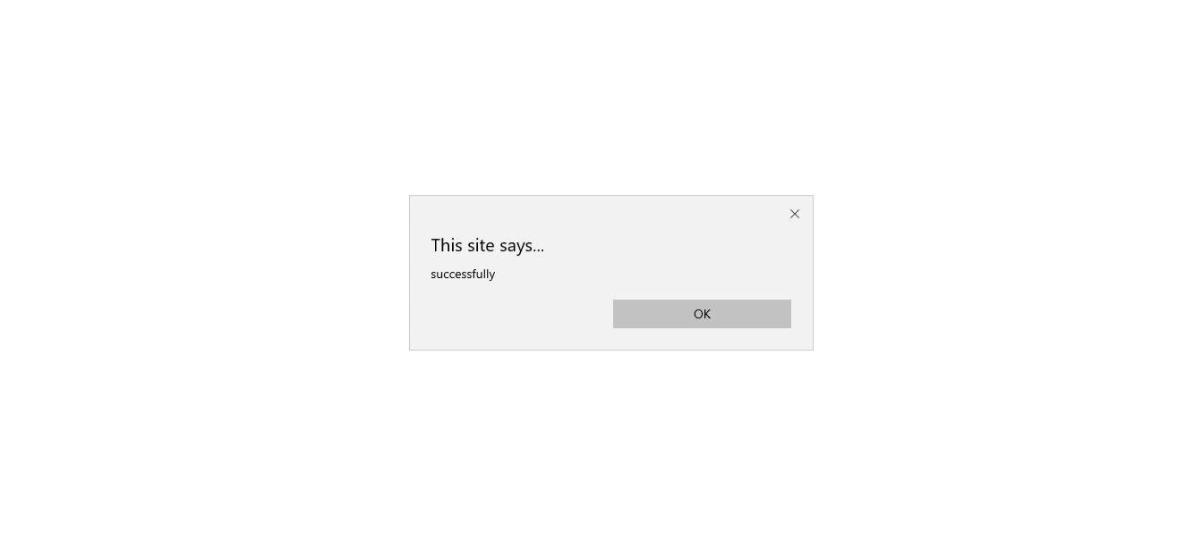

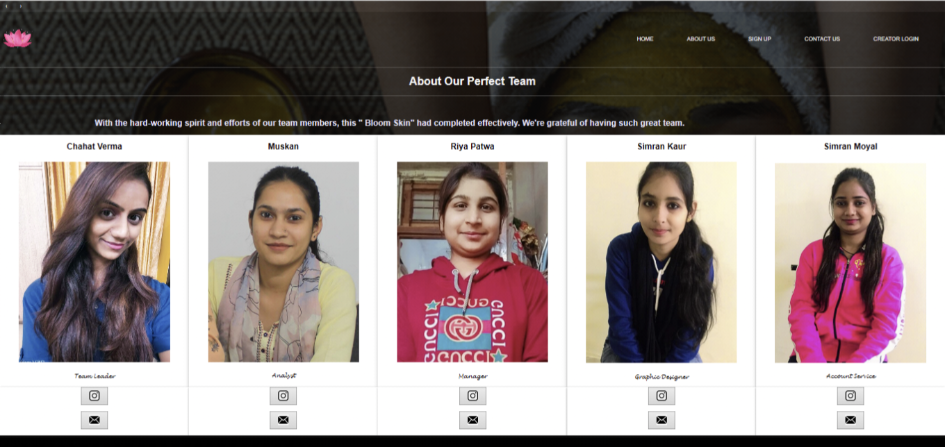**Creator**

**Creator’s Login**

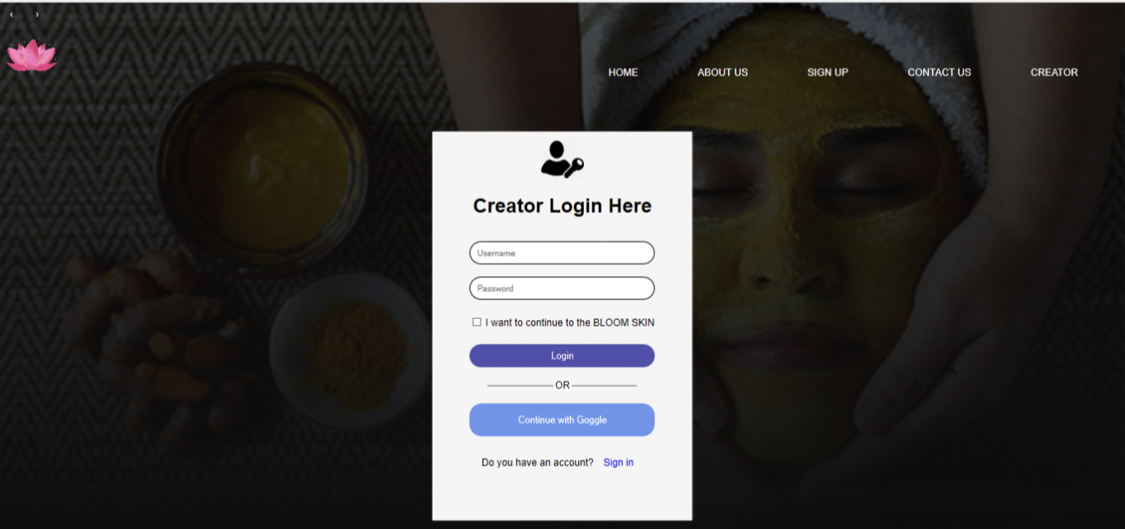

**Creator’s Login Connectivity**

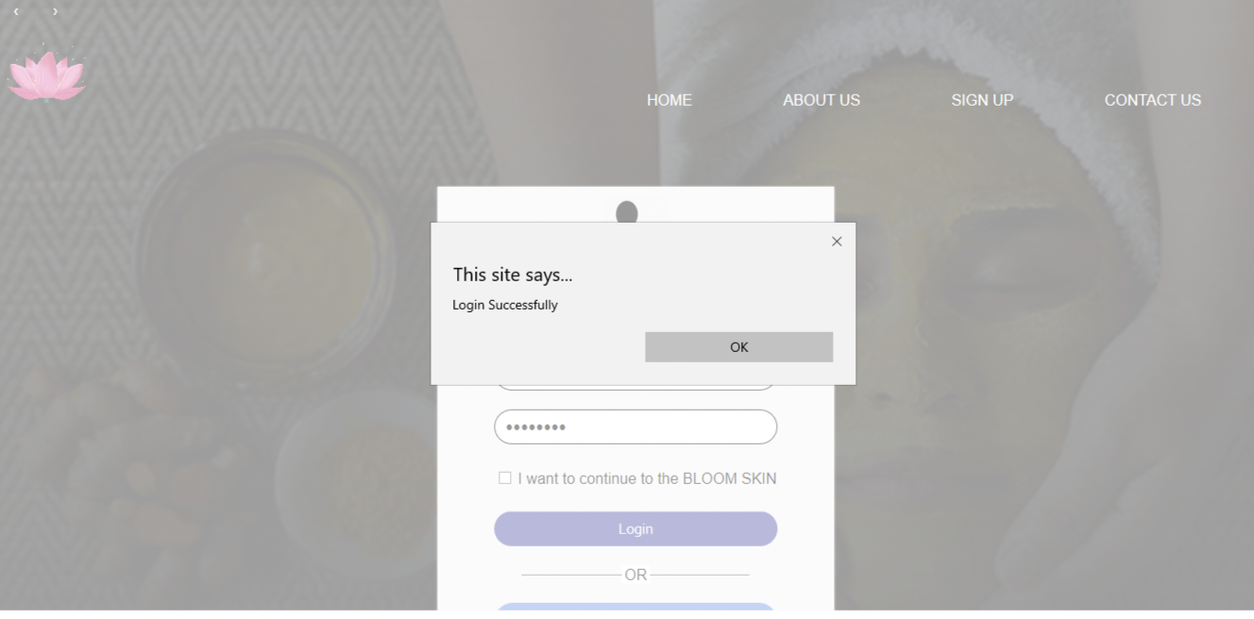

**User’s Login**

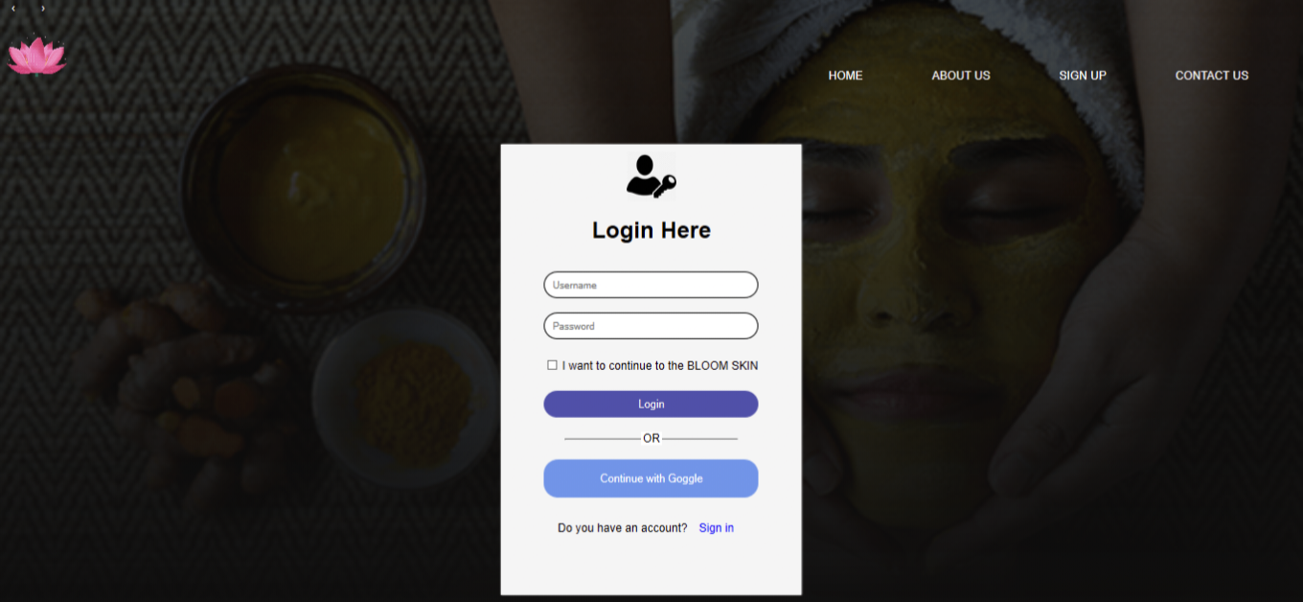

**User’s Login Connectivity**

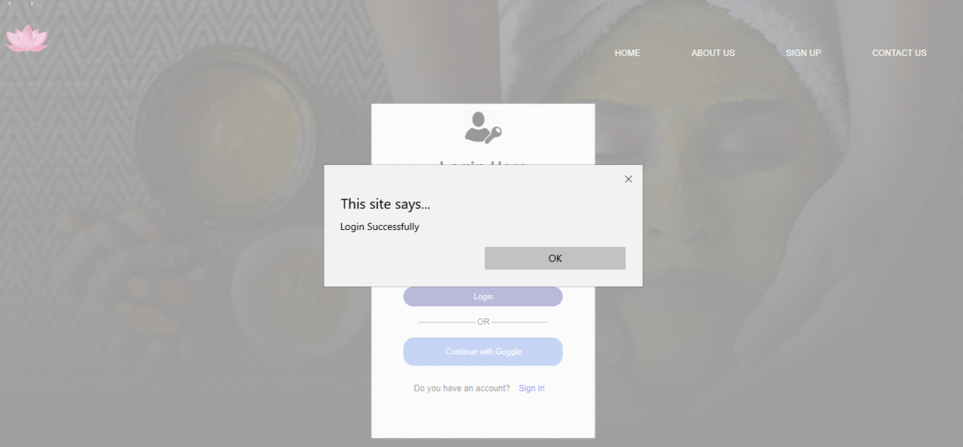

**Solutions**

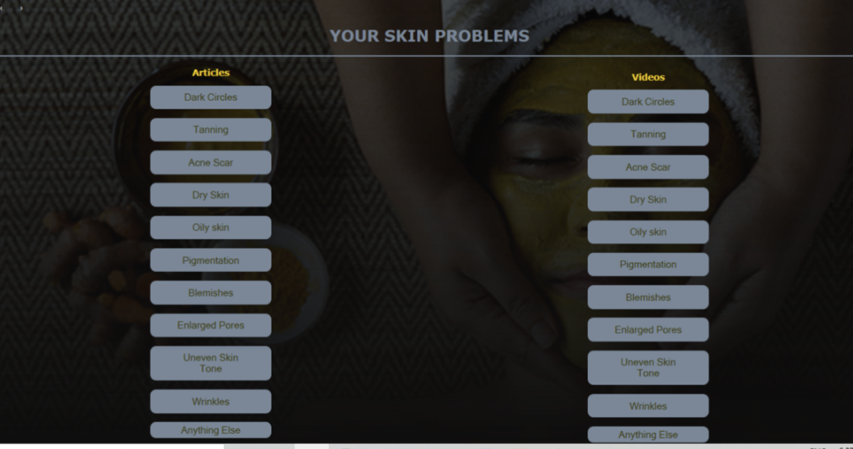

**Dark Circles**

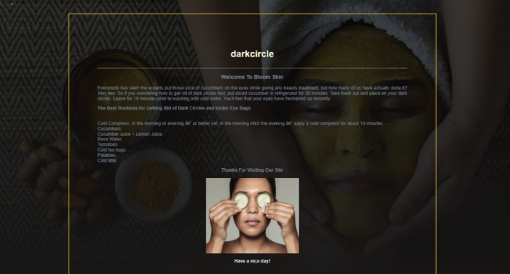

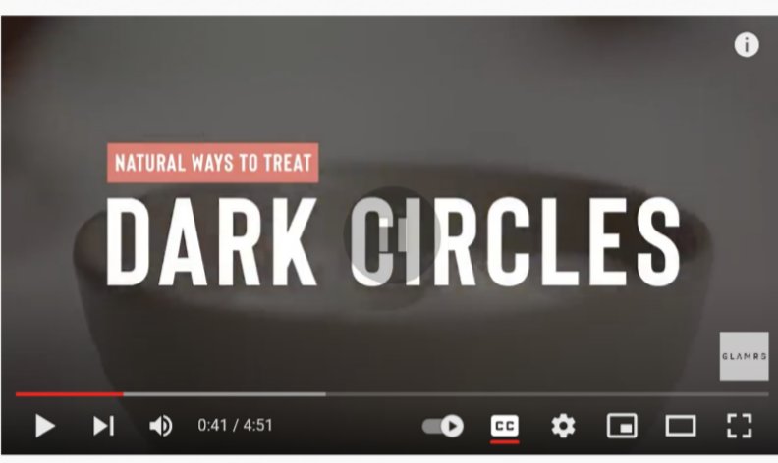

**Pigmentation**

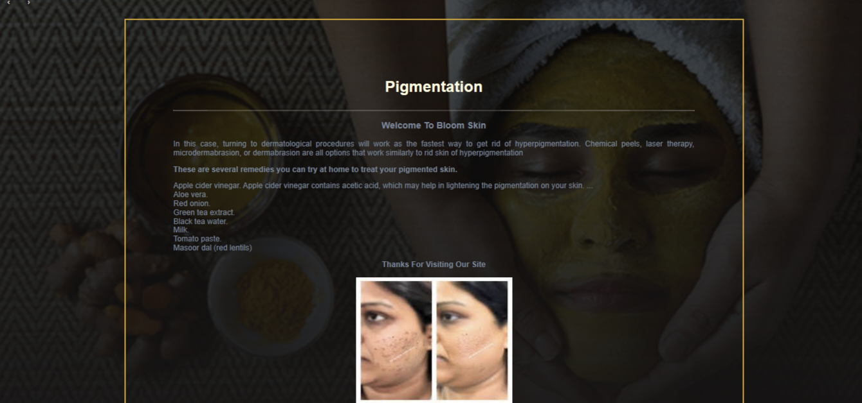

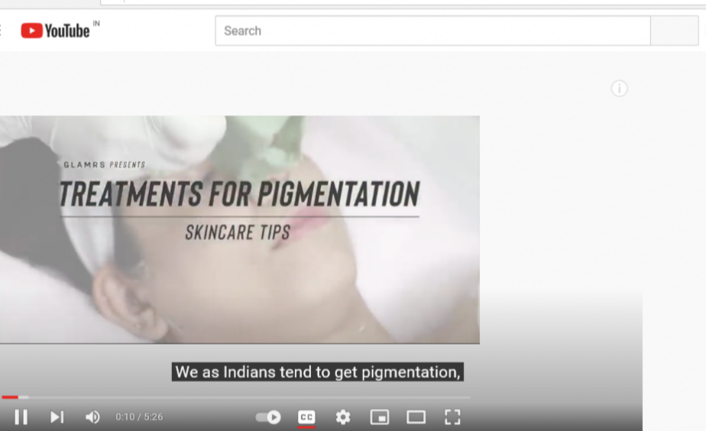

**Acne Scar**

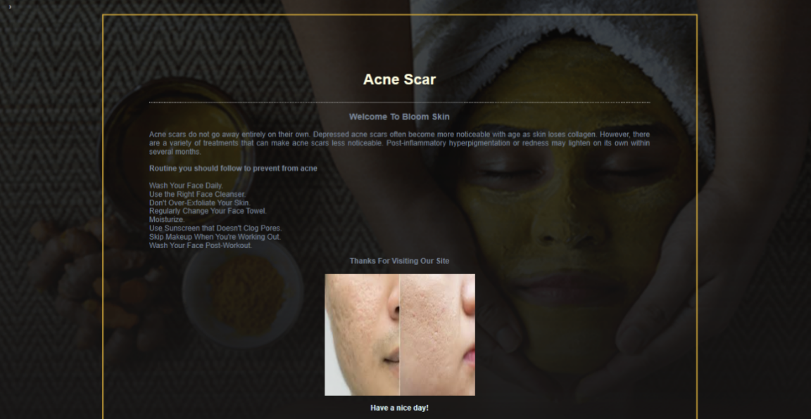

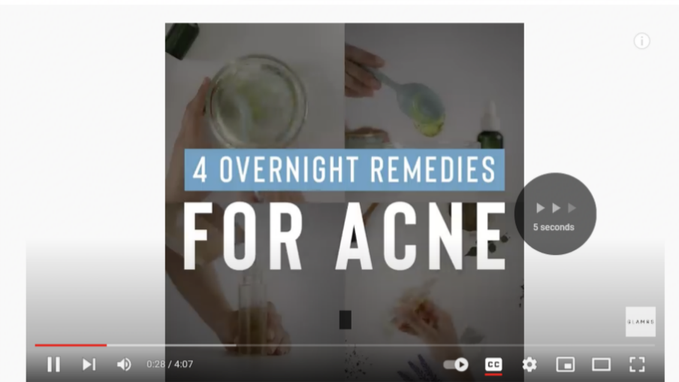

**Blemishes**

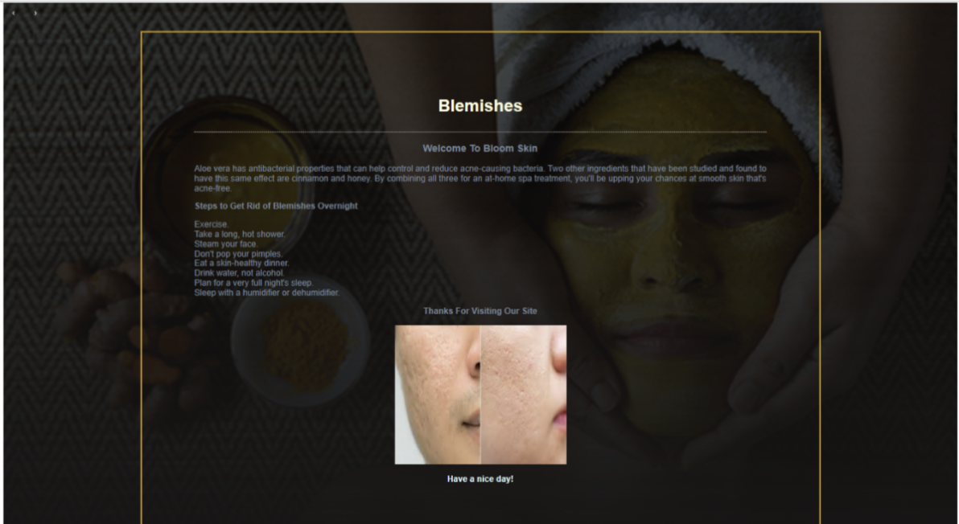

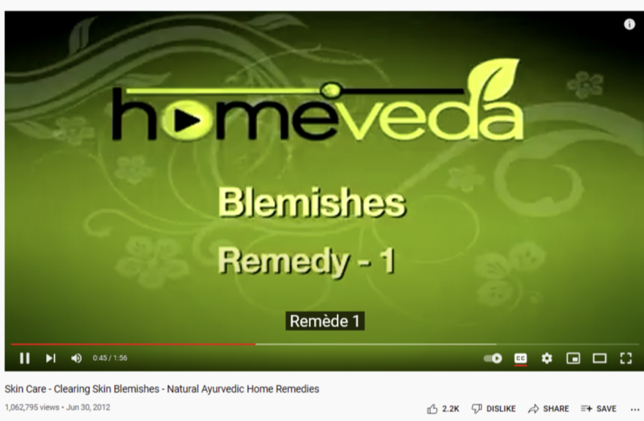

**Anything Else**

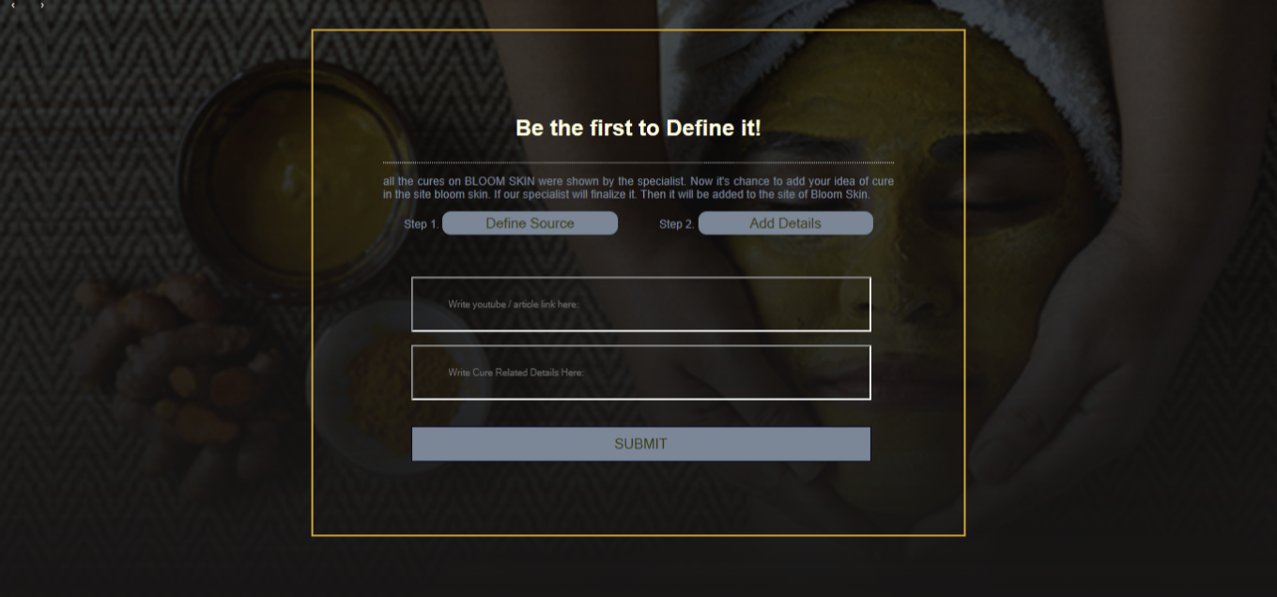

**Anything Else Connectivity**

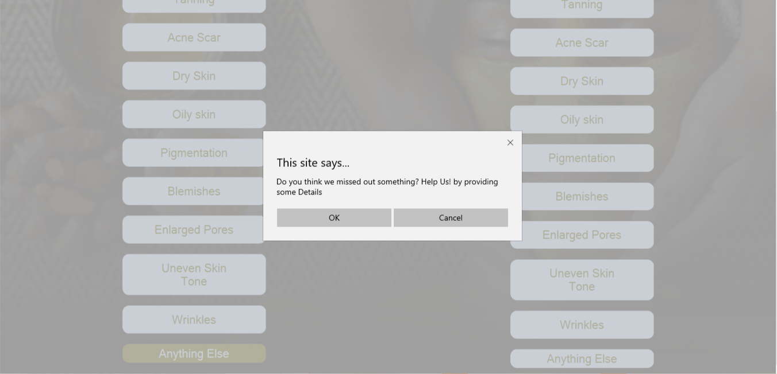

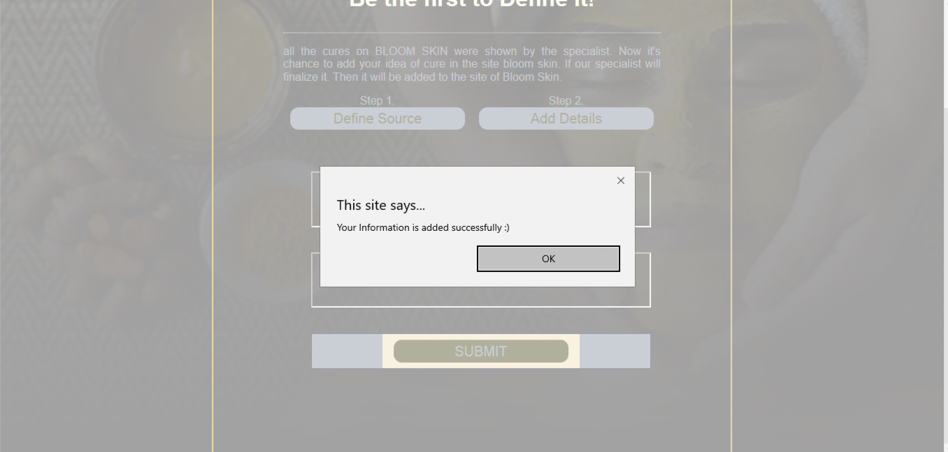

**Reference Login Page**

<html>

<head>

<title>Login Here</title>

<link rel="stylesheet" href="login.css">

</head>

<script>

var input= document.getElementById("input-box2");

input.addEventListener("keyup",function(event)

{

if(event.keyCode===13)

{

event.preventDefault();

document.getElementById("login-btn").click();

}

});

</script>

<a href="bloom.php" class=" previos round">&#8249;</a>

<a href="#" class=" next round"> &#8250;</a>

<body>

<div class="rose">

<nav>

<img src="lotus.gif" class="blogo">

<ul>

<li><a href="bloom.php">HOME</a></li>

<li><a href="about.php">ABOUT US</a></li>

<li><a href="signup.php">SIGN UP</a></li>

<li><a href="contact.php">CONTACT US</a></li>

</ul>

</nav>

</div>

<div class="login-here">

<img src="up1.png">

<h1>Login Here</h1>

<form action="free1.php" method="post">

<input type="text" class="input-box" placeholder="Username" name="n1" value="">

<input type="password" class="input-box" placeholder="Password" name="n2" value="">

<p><span><input type="checkbox"></span> I want to continue to the BLOOM SKIN</p>

<button type="submit" class="login-btn" onclick="window.location.href='bloom.php'"> Login</button></a>

<hr>

<p class="or">OR</p>

<button type="button" class="insta-btn"> <a href="https://mail.google.com">Continue with Goggle</button></a>

<p>Do you have an account?<a href="signup.php" ><font color="blue">Sign in</font></a></p>

</form>

</div>

</body>

</html>

body{

margin: 0;

padding: 0;

font-family: sans-serif;

background-image: linear-gradient(rgba(0,0,0,0.7),#0f0e0e), url(blogin.png);

background-size: cover;

background-position: center;

}

.login-here{

width: 300px;

box-shadow: 0 0 3px 0 whitesmoke;

background: whitesmoke;

padding: 60px;

margin: 1% auto 0;

text-align: center;

}

.login-here h1{

color: black;

margin-bottom: 30px;

}

.input-box{

border-radius: 20px;

padding: 10px;

margin: 10px 0;

width: 100%;

border: 1px solid black;

outline: none;

}

button{

color: whitesmoke;

width: 100%;

padding: 10px;

border-radius: 20px;

font-size: 15px;

margin: 10px 0;

border: none;

outline: none;

cursor: pointer;

}

.login-btn{

background-color: rgb(80, 80, 173);

}

.insta-btn{

background-color: cornflowerblue;

}

a{

text-decoration: none;

color: white;

}

hr{

margin-top: 20px;

width: 80%;

}

.or{

background: white;

width: 30px;

margin: -19px auto 10px ;

}

img{

width: 70px;

margin-top: -50px;

}

.signup{

width: 100%;

height: 100hv;

align-items: center;

justify-content: center;

margin: auto;

}

a{

text-decoration: none;

display: inline-block;

padding: 8px 16px;

}

a:hover{

background-color: wheat;

color: black;

}

.round{

border-radius: 50%;

color: white;

}

nav{

display: flex;

width: 100%;

align-items: center;

flex-wrap: wrap;

padding: 5px 0;

}

.blogo{

width: 100px;

cursor: pointer;

height: 100px;

}

nav ul{

flex: 1;

text-align: right;

padding: 30px;

}

nav ul li{

display: inline-block;

list-style: none;

margin: 10px 30px;

}

nav ul li a{

color: white;

text-decoration:none;

position: relative;

}

nav ul li a::after{

content: '';

width: 0;

height: 3px;

position: absolute;

bottom: -5px;

left: 50%;

transform: translateX(-50%);

background: white;

transition: 0.3s;

}

nav ul li a:hover::after{

width: 50%;

}

.rose{

width: 100%;

height: auto;

margin: auto; }

**Reference Login Page Connectivity**

<?php

$conn=new mysqli('localhost','root','','bloom');

if(!$conn)

{

die('unable to connect');

}

$m1=$_POST['n1'];

$m2=$_POST['n2'];

if($m1=='chahat' && $m2=='password')

echo "<script>alert('Login Successfully');

location.href='bloom.php';</script>";

else

echo "<script>alert('Login Failed');

location.href='login.php';</script>";

mysqli_close($conn);

?>

**Home Page**

<!DOCTYPE html>

<html>

<head>

<meta name="viewport" content="width=device-width, initial-scale=1.0">

<title>BLooM Skin</title>

<link rel="stylesheet" href="bloom.css">

</head>

<body>

<div id="preloader"></div>

<div class="respo">

<div class="container">

<nav>

<img src="lotus.gif" class="blogo">

<ul>

<li><a href="#">HOME</a></li>

<li><a href="about.php"> ABOUT US</a></li>

<li><a href="contact.php">CONTACT US</a></li>

<li><a href="gallery.php">GALLERY</a></li>

</ul>

</nav>

<div class="text-box">

<p>BlooM</p>

<h1>Skin</h1>

<h3>Skincare is essential.Makeup is a choice.</h3>

<div class="row">

<a href="terms.php">TERMS AND CONDITIONS</a>

<a href="login.php">CONTINUE TO BLOOM SKIN <span>&#x2192;</span></a>

<span><br> YOU CAN ENHANCE YOUR BEAUTY. AND GET BEAUTIFUL AND HEALTHY SKIN.</span>

</div>

</div>

<div class="social-icons">

<a href="https://www.facebook.com/"><img src="fb.png"></a>

<a href="https://web.telegram.org"><img src="tele.png"></a>

<a href="https://twitter.com/login"><img src="twitter.png"></a>

<a href="https://www.instagram.com/?hl=en"><img src="insta.png"></a>

<a href="https://login.yahoo.com"><img src="yahoo.png"></a>

</div>

</div>

</div>

<script>

var loader=document.getElementById("preloader");

window.addEventListener("load", function(){

loader.style.display="none";

})

</script>

</body>

</html>

*{

margin: 0;

padding:0;

box-sizing: border-box;

font-family: 'poppins', sans-serif;

}

.container{

width: 100%;

height: 100vh;

background-image: linear-gradient(rgba(0,0,0,0.7),#0f0e0e),url("back3.jpg");

backdrop-filter: blur(8px);

background-repeat: no-repeat;

background-size: cover;

background-position: center;

padding: 0 8%;

position: relative;

}

nav{

display: flex;

width: 100%;

align-items: center;

}

.blogo{

width: 100px;

cursor: pointer;

height: 100px;

}

nav ul{

flex: auto;

text-align: right;

padding: 30px;

}

nav ul li{

display: inline-block;

list-style: none;

margin: 10px 30px;

}

nav ul li a{

color: white;

text-decoration:none;

position: relative;

}

nav ul li a::after{

content: '';

width: 0;

height: 3px;

position: absolute;

bottom: -5px;

left: 50%;

transform: translateX(-50%);

background: white;

transition: 0.3s;

}

nav ul li a:hover::after{

width: 50%;

}

.text-box{

color: papayawhip;

position: absolute;

bottom: 8%;

}

.text-box p{

font-size: 50px;

font-weight: 600;

}

.text-box h1{

font-size: 190px;

line-height: 160px;

margin-left: -10px;

color: transparent;

-webkit-text-stroke: 2px whitesmoke;

background: url(back.jfif);

-webkit-background-clip: text;

background-position: 0 0;

animation: back 20s linear infinite;

}

@keyframes back{

100%{

background-position: 2000px 0;

}

}

.text-box h3{

font-size: 40px;

font-weight:500 ;

}

.text-box .row{

display: flex;

align-items: center;

flex-wrap: wrap;

margin-top: 30px;

}

.text-box a{

color: palegoldenrod;

text-decoration: none;

padding: 10px 20px;

margin-right: 20px;

border: 2px solid palegoldenrod;

}

.text-box a span{

font-size: 30px;

line-height: 15px;

margin-left: 5px;

}

.social-icons{

position: absolute;

right: 5%;

bottom: 15%;

}

.social-icons img{

width: 25px;

display: block;

margin: 25px 5px;

}

.loader {

border: 16px solid gold;

border-radius: 50%;

width: 120px;

height: 120px;

animation: spin 2s linear infinite;

}

@keyframes spin {

0% { transform: rotate(0deg); }

100% { transform: rotate(360deg);

}

}

@media only screen and( max-width:700px){

}

#preloader{

background: #000 url(pre.gif) no-repeat center;

background-size: 30%;

height: 100vh;

width: 100%;

position: fixed;

z-index: 100;

}

**About Us**

<html>

<head>

<title>About Us!</title>

<link rel="stylesheet" href="about.css">

</head>

<a href="bloom.php" class=" previos round">&#8249;</a>

<a href="#" class=" next round"> &#8250;</a>

<body>

<nav id="navbar">

<img src="lotus.gif" class="blogo">

<ul id="menu">

<li><a href="bloom.php">HOME</a></li>

<li><a href="about.php">ABOUT US</a></li>

<li><a href="signup.php">SIGN UP</a></li>

<li><a href="contact.php">CONTACT US</a></li>

</ul>

</nav>

<div class="about-us">

<h1 style="text-align: center;">About us!</h1><hr style="border: 1px dotted lightgray">

<h3 style="text-align: center; ">Welcome To <span id="W_Name1">Bloom Skin</span></h3>

<p><span id="W_type1">Beauty & care</span> Platform. Here we will provide you only intresting content, which you will like very much. We're dedicated to providing you the best of <span id="W_Type2"> Beauty & care</span>, with a focus on dependability and <span id="W_Spec"> Solutions to Skin Related Problems</span>. We're working to turn our passion for <span id="W_Type3"> Beauty & Care</span> into a blooming online website. We hope you enjoy our <span id="W_type4"> Beauty & care</span> as much as we enjoy offering them to you. </p>

<p> I will keep posting more important posts on my website for all of you.Please give your support and love. <br> <br> We are trying to enhance your beauty by giving you some tips and tricks.</p>

<p><b> The Greatest Advantages of Using Natural Remedies</b></p>

A chance to solve your health issues naturally. <br>

Ingredients used for hundreds of years. <br>

Support a healthy lifestyle. <br>

Natural remedies and folk medicine. <br>

Inexpensive. <br><br>

<p style="font-weight: bold; text-align: center;">Thanks For Visiting Our Site <br><br>

<span style="color:lightcyan; font-size: 16px;font-weight: bold;text-align: center;">Have a nice day!</span></p>

</div>

</body>

</html>

body{

margin: 0;

padding: 0;

font-family: sans-serif;

background-image: linear-gradient(rgba(0,0,0,0.7),#181616), url(blogin.png);

background-size: cover;

background-position: center;

}

.about-us{

width: 40%;

border: 2PX solid goldenrod;

padding: 100px;

text-align: justify;

margin: auto;

height: auto;

color: lightslategray;

}

.about-us h1{

color: lightyellow;

margin-bottom: 30px;

}

nav{

display: flex;

width: 100%;

align-items: center;

flex-wrap: wrap;

padding: 5px 0;

}

nav ul{

flex: 1;

text-align: right;

padding: 30px;

}

nav ul li{

display: inline-block;

list-style: none;

margin: 10px 30px;

}

nav ul li a{

color: white;

text-decoration:none;

position: relative;

}

nav ul li a::after{

content: '';

width: 0;

height: 3px;

position: absolute;

bottom: -5px;

left: 50%;

transform: translateX(-50%);

background: white;

transition: 0.3s;

}

nav ul li a:hover::after{

width: 50%;

}

.blogo{

width: 100px;

cursor: pointer;

height: 100px;

}

a{

text-decoration: none;

display: inline-block;

padding: 8px 16px;

}

a:hover{

background-color: wheat;

color: black;

}

.round{

border-radius: 50%;

color: white;

}

**Contact Us**

<html>

<head lang="en">

<meta charset="UTF-8">

<meta http-equiv="X-UA-Compatible" content="width=device-width, initial-scale=1.0">

<link rel="stylesheet" href="contact.css">

<title>CONTACT US</title>

</head>

<body>

<div id="preloader"></div>

<div class="rose">

<a href="bloom.php" class=" previos round">&#8249;</a>

<a href="" class=" next round"> &#8250;</a>

<nav>

<img src="lotus.gif" class="blogo">

<ul>

<li><a href="bloom.php">HOME</a></li>

<li><a href="about.php">ABOUT US</a></li>

<li><a href="signup.php">SIGN UP</a></li>

<li><a href="member.php">CREATOR </a></li>

<li><a href="creator.php">CREATOR LOGIN</a></li>

</ul>

<div class="hero">

<h1 style="text-align: center;">Contact Us!</h1><hr style="border: 1px dotted lightgray"> <br><br>

<form action="contact1.php" method="post">

<div class="row">

<div class="input-group">

<input type="name" id="name" required name="n1" value="">

<label for="name"> Your Name</label>

</div>

<div class="input-group">

<input type="number" id="number" required name="n2" value="">

<label for="number">Phone No.</label>

</div>

</div>

<div class="input-group">

<div class="input-group">

<input type="email" id="email" required name="n3" value="">

<label for="email">Email Id</label>

</div>

<div class="input-group">

<textarea id="message" rows="10"required name="n4" value=""></textarea>

<label for="message">Your Message</label>

</div>

<button type="submit">SUBMIT</button>

</form>

</div>

</nav>

</div>

<script>

var loader=document.getElementById("preloader");

window.addEventListener("load", function(){

loader.style.display="none";

})

</script>

</body>

</html>

*{

margin: 0;

padding: 0;

font-family: 'poppins', sans-serif;

box-sizing: border-box;

}

.hero{

width: 100%;

height: 100hv;

align-items: center;

justify-content: center;

margin: auto;

}

form{

width: 90%;

max-width: 600px;

margin: auto;

align-content: center;

}

.input-group{

margin-bottom: 30px;

position: relative;

}

input, textarea{

width: 100%;

padding: 10px;

outline: 0;

border: 1px solid #fff;

color: #fff;

background: transparent;

font-size: 15px;

}

label{

height: 100%;

position: absolute;

left: 0;

top: 0;

padding: 10px;

color: #fff;

cursor: text;

transition: 0.8s;

}

button{

padding: 10px 0;

color: #fff;

outline: none;

background: transparent;

border: 1px solid #fff;

width: 100%;

cursor: pointer;

}

input:focus~label,

input:valid~label,

textarea:focus~label,

textarea:valid~label{

top: -35px;

font-size: 14px;

}

.row{

display: flex;

align-items: center;

justify-content: space-between;

}

.row .input-group{

flex-basis: 40%;

}

.hero h1{

color: lightyellow;

margin-bottom: 30px;

}

nav{

display: flex;

width: 100%;

align-items: center;

flex-wrap: wrap;

padding: 5px 0;

}

.blogo{

width: 100px;

cursor: pointer;

height: 100px;

}

nav ul{

flex: 1;

text-align: right;

padding: 30px;

}

nav ul li{

display: inline-block;

list-style: none;

margin: 10px 30px;

}

nav ul li a{

color: white;

text-decoration:none;

position: relative;

}

nav ul li a::after{

content: '';

width: 0;

height: 3px;

position: absolute;

bottom: -5px;

left: 50%;

transform: translateX(-50%);

background: white;

transition: 0.3s;

}

nav ul li a:hover::after{

width: 50%;

}

.rose{

width: 100%;

height: auto;

background-image: linear-gradient(rgba(0,0,0,0.7),#0f0e0e), url(blogin.png);

background-position: center;

background-size: cover;

align-items: center;

justify-content: center;

margin: auto;

}

a{

text-decoration: none;

display: inline-block;

padding: 8px 16px;

}

a:hover{

background-color: wheat;

color: black;

}

.round{

border-radius: 50%;

color: white;

}

#preloader{

background: #000 url(pre.gif) no-repeat center;

background-size: 30%;

height: 100vh;

width: 100%;

position: fixed;

z-index: 100;

}

**Contact Connectivity**

<?php

$conn=new mysqli('localhost','root','','bloom');

if(!$conn)

{

die('unable to connect');

}

$m1=$_POST['n1'];

$m2=$_POST['n2'];

$m3=$_POST['n3'];

$m4=$_POST['n4'];

$l=strlen($m2);

if($l<10)

echo "<script>alert('Length is too short :)');

location.href='contact.php';</script>";

if($l>10)

echo "<script>alert('Length is too long :)');

location.href='contact.php';</script>";

else

$sql="insert into contact values('$m1','$m2','$m3','$m4');";

if(mysqli_query($conn,$sql))

echo "<script>alert('Your Information is added succesfully :)');

location.href='bloom.php';</script>";

else

echo "<script>alert(' Try again');</script>";

mysqli_close($conn);

?>

**Structure Of Contact Table**

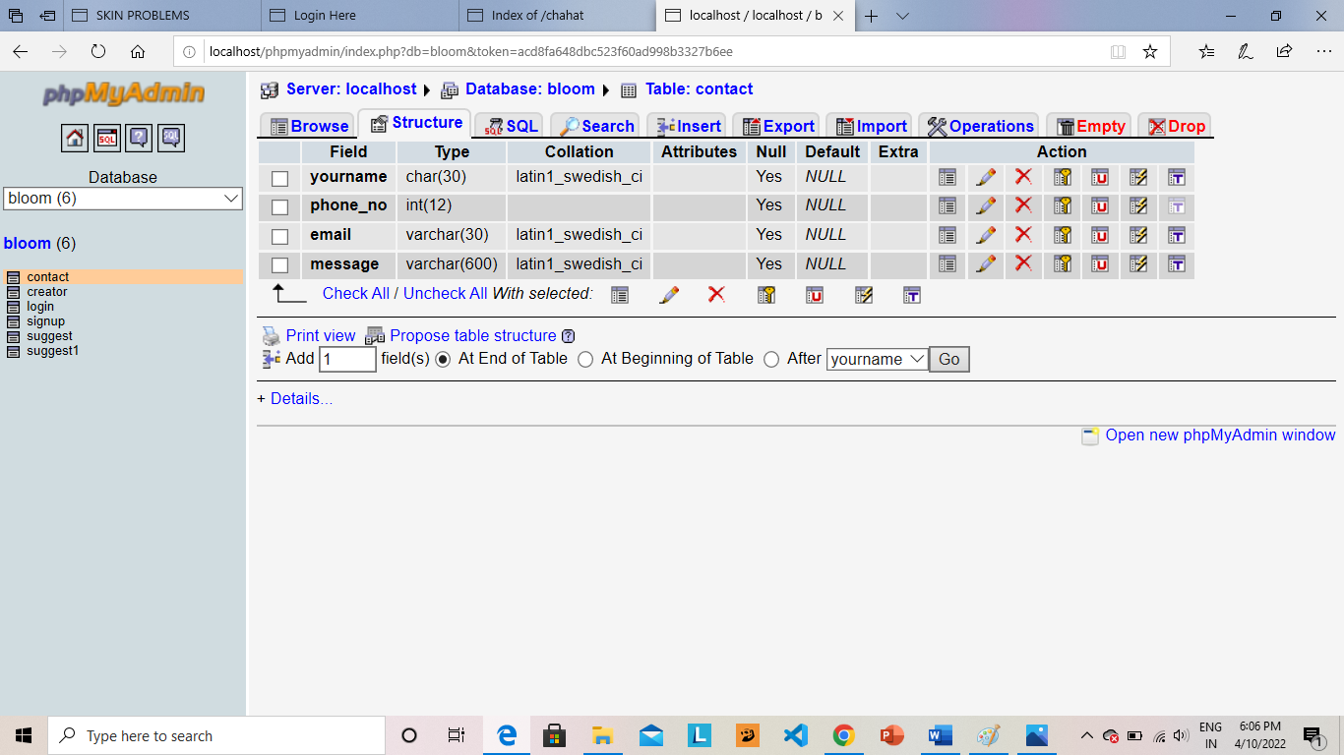

**Browser Of Contact Table**

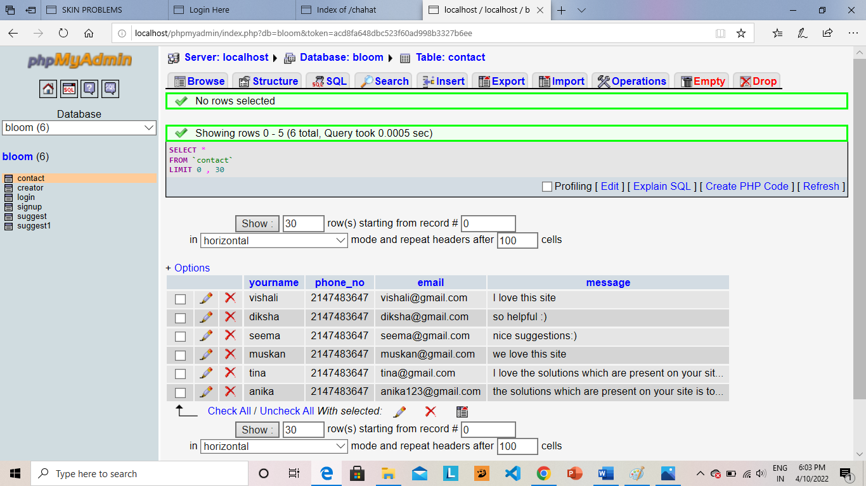

**SQL Of Contact Table**

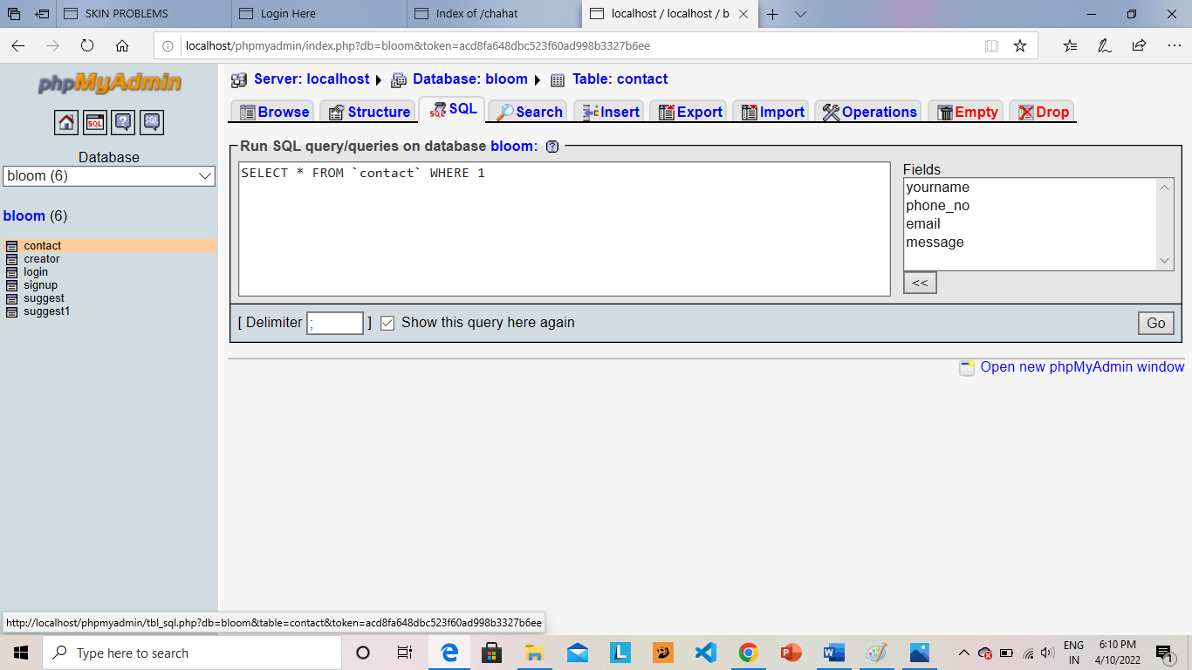

**Sign-Up Page**

<html>

<head>

<title>signup Here</title>

<link rel="stylesheet" href="signup.css">

</head>

<a href="bloom.php" class=" previos round">&#8249;</a>

<a href="" class=" next round"> &#8250;</a>

<body>

<div class="rose">

<nav>

<img src="lotus.gif" class="blogo">

<ul>

<li><a href="bloom.php">HOME</a></li>

<li><a href="about.php">ABOUT US</a></li>

<li><a href="signup.php">SIGN UP</a></li>

<li><a href="contact.php">CONTACT US</a></li>

</ul>

</nav>

</div>

<div class="signup">

<img src="up1.png">

<h1>Register Here</h1>

<form action="signup1.php" method="post">

<input type="text" class="input-box" placeholder="Username" name="n1" value="">

<input type="email" class="input-box" placeholder="Your email" name="n2" value="">

<input type="password" class="input-box" placeholder="Password" name="n3" value="">

<input type="password" class="input-box" placeholder=" Confirm Password" name="n4" value="">

<p><span><input type="checkbox"></span> I want to continue to the BLOOM SKIN</p>

<button type="submit" class="login-btn"> Sign Up</button>

<hr>

<p class="or">OR</p>

<button type="button" class="insta-btn"> <a href="https://mail.google.com">Continue with Goggle</button></a>

</form>

</div>

</body>

</html>

body{

margin: 0;

padding: 0;

font-family: sans-serif;

background-image: linear-gradient(rgba(0,0,0,0.7),#0f0e0e), url(blogin.png);

background-size: cover;

background-position: center;

}

.signup{

width: 300px;

box-shadow: 0 0 3px 0 whitesmoke;

background: whitesmoke;

padding: 60px;

margin: 1% auto 0;

text-align: center;

}

.sign h1{

color: black;

margin-bottom: 30px;

}

.input-box{

border-radius: 20px;

padding: 10px;

margin: 10px 0;

width: 100%;

border: 1px solid black;

outline: none;

}

button{

color: whitesmoke;

width: 100%;

padding: 10px;

border-radius: 20px;

font-size: 15px;

margin: 10px 0;

border: none;

outline: none;

cursor: pointer;

}

.login-btn{

background-color: rgb(80, 80, 173);

}

.insta-btn{

background-color: cornflowerblue;

}

a{

text-decoration: none;

}

hr{

margin-top: 20px;

width: 80%;

}

.or{

background: white;

width: 30px;

margin: -19px auto 10px ;

}

img{

width: 70px;

margin-top: -50px;

}

a{

color: white;

}

.rose{

width: 100%;

height: auto;

margin: auto;

}

nav{

display: flex;

width: 100%;

align-items: center;

flex-wrap: wrap;

padding: 5px 0;

}

.blogo{

width: 100px;

cursor: pointer;

height: 100px;

position: fixed;

}

nav ul{

flex: 1;

text-align: right;

padding: 30px;

}

nav ul li{

display: inline-block;

list-style: none;

margin: 10px 30px;

}

nav ul li a{

color: white;

text-decoration:none;

position: relative;

}

nav ul li a::after{

content: '';

width: 0;

height: 3px;

position: absolute;

bottom: -5px;

left: 50%;

transform: translateX(-50%);

background: white;

transition: 0.3s;

}

nav ul li a:hover::after{

width: 50%;

}

a{

text-decoration: none;

display: inline-block;

padding: 8px 16px;

}

a:hover{

background-color: whitesmoke;

color: black;

}

.round{

border-radius: 50%;

color: white;

}

**Sign-Up Connectivity**

<?php

$conn=new mysqli('localhost','root','','bloom');

if(!$conn)

{

die('unable to connect');

}

$m1=$_POST['n1'];

$m2=$_POST['n2'];

$m3=$_POST['n3'];

$m4=$_POST['n4'];

$sql="insert into signup values('$m1','$m2','$m3','$m4');";

if($m3==$m4)

echo "<script>alert('successfully');

location.href='login.php';</script>";

else

echo "<script>alert('check password');

location.href='signup.php';</script>";

if(mysqli_query($conn,$sql))

echo "<script>alert('Login Successfully');

location.href='login.php';</script>";

else

echo "<script>alert('Login Failed');

location.href='bloom.php';</script>";

mysqli_close($conn);

?>

**Structure Of Sign-up Table**

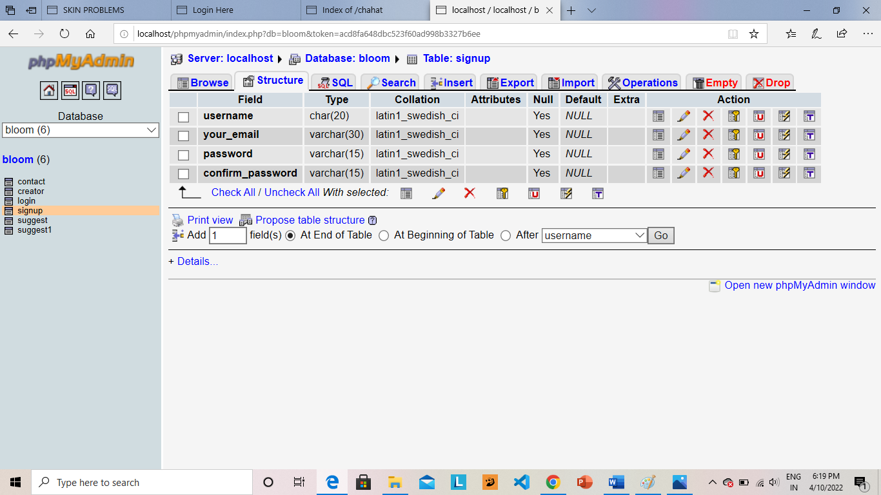

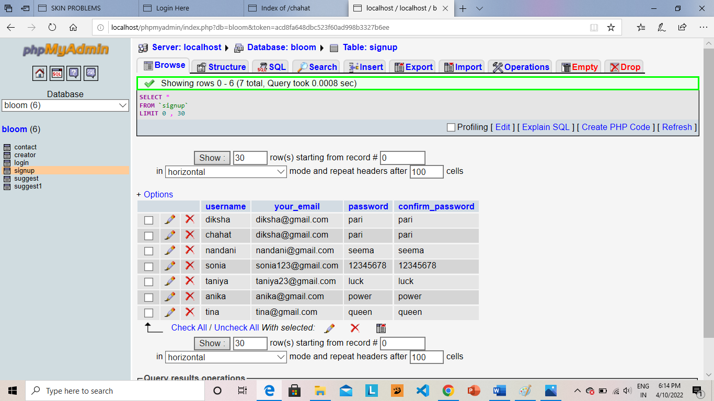 **Browser of Sign-up Table**

**SQL Of Sign-up Table**

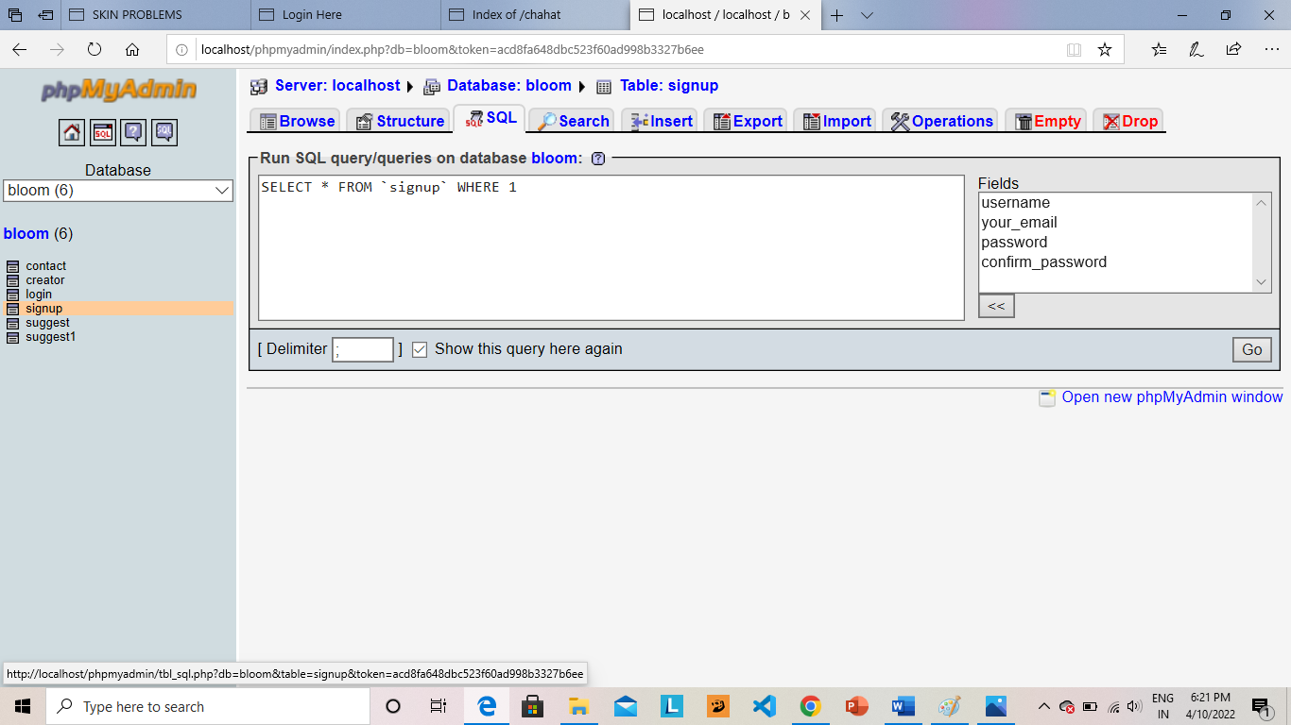

**Creator’s Login**

<html>

<head>

<title>Creator Login Here</title>

<link rel="stylesheet" href="creator.css">

</head>

<script>

var input= document.getElementById("input-box2");

input.addEventListener("keyup",function(event)

{

if(event.keyCode===13)

{

event.preventDefault();

document.getElementById("login-btn").click();

}

});

</script>

<a href="bloom.php" class=" previos round">&#8249;</a>

<a href="#" class=" next round"> &#8250;</a>

<body>

<div class="rose">

<nav>

<img src="lotus.gif" class="blogo">

<ul>

<li><a href="bloom.php">HOME</a></li>

<li><a href="about.php">ABOUT US</a></li>

<li><a href="signup.php">SIGN UP</a></li>

<li><a href="contact.php">CONTACT US</a></li>

<li><a href="member.php">CREATOR </a></li>

</ul>

</nav>

</div>

<div class="login-here">

<img src="up1.png">

<h1> Creator Login Here</h1>

<form action="creator1.php" method="post">

<input type="text" class="input-box" placeholder="Username" name="n1" value="">

<input type="password" class="input-box" placeholder="Password" name="n2" value="">

<p><span><input type="checkbox"></span> I want to continue to the BLOOM SKIN</p>

<button type="submit" class="login-btn" onclick="window.location.href='bloom.php'"> Login</button></a>

<hr>

<p class="or">OR</p>

<button type="button" class="insta-btn"> <a href="https://mail.google.com">Continue with Goggle</button></a>

<p>Do you have an account?<a href="signup.php" ><font color="blue">Sign in</font></a></p>

</form>

</div>

</body>

</html>

body{

margin: 0;

padding: 0;

font-family: sans-serif;

background-image: linear-gradient(rgba(0,0,0,0.7),#0f0e0e), url(blogin.png);

background-size: cover;

background-position: center;

}

.login-here{

width: 300px;

box-shadow: 0 0 3px 0 whitesmoke;

background: whitesmoke;

padding: 60px;

margin: 1% auto 0;

text-align: center;

}

.login-here h1{

color: black;

margin-bottom: 30px;

}

.input-box{

border-radius: 20px;

padding: 10px;

margin: 10px 0;

width: 100%;

border: 1px solid black;

outline: none;

}

button{

color: whitesmoke;

width: 100%;

padding: 10px;

border-radius: 20px;

font-size: 15px;

margin: 10px 0;

border: none;

outline: none;

cursor: pointer;

background-color: black;

}

.login-btn{

background-color: rgb(80, 80, 173);

}

.insta-btn{

background-color: cornflowerblue;

}

a{

text-decoration: none;

color: white;

}

hr{

margin-top: 20px;

width: 80%;

}

.or{

background: white;

width: 30px;

margin: -19px auto 10px ;

}

img{

width: 70px;

margin-top: -50px;

}

.signup{

width: 100%;

height: 100hv;

align-items: center;

justify-content: center;

margin: auto;

}

a{

text-decoration: none;

display: inline-block;

padding: 8px 16px;

}

a:hover{

background-color: wheat;

color: black;

}

.round{

border-radius: 50%;

color: white;

}

nav{

display: flex;

width: 100%;

align-items: center;

flex-wrap: wrap;

padding: 5px 0;

}

.blogo{

width: 100px;

cursor: pointer;

height: 100px;

}

nav ul{

flex: 1;

text-align: right;

padding: 30px;

}

nav ul li{

display: inline-block;

list-style: none;

margin: 10px 30px;

}

nav ul li a{

color: white;

text-decoration:none;

position: relative;

}

nav ul li a::after{

content: '';

width: 0;

height: 3px;

position: absolute;

bottom: -5px;

left: 50%;

transform: translateX(-50%);

background: white;

transition: 0.3s;

}

nav ul li a:hover::after{

width: 50%;

}

.rose{

width: 100%;

height: auto;

margin: auto;}

**Creator’s Login Connectivity**

<?php

$conn=new mysqli('localhost','root','','bloom');

if(!$conn)

{

die('unable to connect');

}

$m1=$_POST['n1'];

$m2=$_POST['n2'];

if($m1=='chahat' && $m2=='password')

echo "<script>alert('Login Successfully');

location.href='bloom.php';</script>";

else

echo "<script>alert('Login Failed');

location.href='creator.php';</script>";

mysqli_close($conn);

?>

**Terms And Conditions**

<html>

<head>

<title>Login Here</title>

<link rel="stylesheet" href="terms.css">

</head>

<a href="bloom.php" class=" previos round">&#8249;</a>

<a href="" class=" next round"> &#8250;</a>

<body>

<div class="terms" >

<p>&nbsp;</p><h2 style="text-align: center; color: cadetblue;"<b> TERMS AND CONDITIONS</b></h2>

<p>Last updated: 2022-01-15</p>

<font color="white"p> 1. <b> Introduction</b></p></font>

<p>Welcome to <b>Bloom Skin</b> <q>Company</q> ,<q> we </q>,<q> our </q>,<q> us </q>)!</p>

<p>These Terms of Service (<q> Terms </q>,<q> Terms of Service</q>) govern your use of our website located at <b>Bloom Skin.com</b> (together or individually <q> Service </q>) operated by <b>Bloom Skin</b>.</p>

<p>Our Privacy Policy also governs your use of our Service and explains how we collect, safeguard and disclose information that results from your use of our web pages.</p>

<p>Your agreement with us includes these Terms and our Privacy Policy (<q> Agreements</q>). You acknowledge that you have read and understood Agreements, and agree to be bound of them.</p>

<p>If you do not agree with (or cannot comply with) Agreements, then you may not use the Service, but please let us know by emailing at <b>bloomskin2021@gmail.com</b> so we can try to find a solution. These Terms apply to all visitors, users and others who wish to access or use Service.</p>

<font color="white"> <p>2. <b>Communications</b></p></font>

<p>By using our Service, you agree to subscribe to newsletters, marketing or promotional materials and other information we may send. However, you may opt out of receiving any, or all, of these communications from us by following the unsubscribe link or by emailing at bloomskin2021@gmail.com.</p>

<font color="white"><p>3. <b>Contests, Sweepstakes and Promotions</b></p></font>

<p>Any contests, sweepstakes or other promotions (collectively,<q> Promotions</q>) made available through Service may be governed by rules that are separate from these Terms of Service. If you participate in any Promotions, please review the applicable rules as well as our Privacy Policy. If the rules for a Promotion conflict with these Terms of Service, Promotion rules will apply.</p>

<font color="white"><p>4. <b>Content</b></p></font><p>Content found on or through this Service are the property of Bloom Skin or used with permission. You may not distribute, modify, transmit, reuse, download, repost, copy, or use said Content, whether in whole or in part, for commercial purposes or for personal gain, without express advance written permission from us.</p>

<font color="white"><p>5. <b>Prohibited Uses</b></p></font>

<p>You may use Service only for lawful purposes and in accordance with Terms. You agree not to use Service:</p>

<p>0.1. In any way that violates any applicable national or international law or regulation.</p>

<p>0.2. For the purpose of exploiting, harming, or attempting to exploit or harm minors in any way by exposing them to inappropriate content or otherwise.</p>

<p>0.3. To transmit, or procure the sending of, any advertising or promotional material, including any <q> junk mail</q>,<q> chain letter,</q><q> spam,</q> or any other similar solicitation.</p>

<p>0.4. To impersonate or attempt to impersonate Company, a Company employee, another user, or any other person or entity.</p>

<p>0.5. In any way that infringes upon the rights of others, or in any way is illegal, threatening, fraudulent, or harmful, or in connection with any unlawful, illegal, fraudulent, or harmful purpose or activity.</p>

<p>0.6. To engage in any other conduct that restricts or inhibits anyone’s use or enjoyment of Service, or which, as determined by us, may harm or offend Company or users of Service or expose them to liability.</p>

<p>Additionally, you agree not to:</p>

<p>0.1. Use Service in any manner that could disable, overburden, damage, or impair Service or interfere with any other party’s use of Service, including their ability to engage in real time activities through Service.</p>

<p>0.2. Use any robot, spider, or other automatic device, process, or means to access Service for any purpose, including monitoring or copying any of the material on Service.</p>

<p>0.3. Use any manual process to monitor or copy any of the material on Service or for any other unauthorized purpose without our prior written consent.</p>

<p>0.4. Use any device, software, or routine that interferes with the proper working of Service.</p>

<p>0.5. Introduce any viruses, trojan horses, worms, logic bombs, or other material which is malicious or technologically harmful.</p>

<p>0.6. Attempt to gain unauthorized access to, interfere with, damage, or disrupt any parts of Service, the server on which Service is stored, or any server, computer, or database connected to Service.</p>

<p>0.7. Attack Service via a denial-of-service attack or a distributed denial-of-service attack.</p>

<p>0.8. Take any action that may damage or falsify Company rating.</p>

<p>0.9. Otherwise attempt to interfere with the proper working of Service.</p>

<font color="white"><p>6. <b>Analytics</b></p></font>

<p>We may use third-party Service Providers to monitor and analyze the use of our Service.</p>

<font color="white"> <p>7. <b>No Use By Minors</b></p></font>

<p>Service is intended only for access and use by individuals at least eighteen (18) years old. By accessing or using Service, you warrant and represent that you are at least eighteen (18) years of age and with the full authority, right, and capacity to enter into this agreement and abide by all of the terms and conditions of Terms. If you are not at least eighteen (18) years old, you are prohibited from both the access and usage of Service.</p>

<font color="white"><p>8. <b>Accounts</b></p></font><p>When you create an account with us, you guarantee that you are above the age of 18, and that the information you provide us is accurate, complete, and current at all times. Inaccurate, incomplete, or obsolete information may result in the immediate termination of your account on Service.</p><p>You are responsible for maintaining the confidentiality of your account and password, including but not limited to the restriction of access to your computer and/or account. You agree to accept responsibility for any and all activities or actions that occur under your account and/or password, whether your password is with our Service or a third-party service. You must notify us immediately upon becoming aware of any breach of security or unauthorized use of your account.</p><p>You may not use as a username the name of another person or entity or that is not lawfully available for use, a name or trademark that is subject to any rights of another person or entity other than you, without appropriate authorization. You may not use as a username any name that is offensive, vulgar or obscene.</p><p>We reserve the right to refuse service, terminate accounts, remove or edit content, or cancel orders in our sole discretion.</p>

<font color="white"><p>9. <b>Intellectual Property</b></p></font>

<p>Service and its original content (excluding Content provided by users), features and functionality are and will remain the exclusive property of Bloom Skin and its licensors. Service is protected by copyright, trademark, and other laws of and foreign countries. Our trademarks may not be used in connection with any product or service without the prior written consent of Bloom Skin.</p>

<font color="white"> <p>10. <b>Copyright Policy</b></p></font>

<p>We respect the intellectual property rights of others. It is our policy to respond to any claim that Content posted on Service infringes on the copyright or other intellectual property rights (<q> Infringement</q>) of any person or entity.</p>

<p>If you are a copyright owner, or authorized on behalf of one, and you believe that the copyrighted work has been copied in a way that constitutes copyright infringement, please submit your claim via email to bloomskin2021@gmail.com, with the subject line: <q> Copyright Infringement</q> and include in your claim a detailed description of the alleged Infringement as detailed below, under <q> DMCA Notice and Procedure for Copyright Infringement Claims</q></p>

<p>You may be held accountable for damages (including costs and attorneys’ fees) for misrepresentation or bad-faith claims on the infringement of any Content found on and/or through Service on your copyright.</p>

<font color="white"><p>11. <b>DMCA Notice and Procedure for Copyright Infringement Claims</b></p></font>

<p>You may submit a notification pursuant to the Digital Millennium Copyright Act (DMCA) by providing our Copyright Agent with the following information in writing (see 17 U.S.C 512(c)(3) for further detail):</p>

<p>0.1. an electronic or physical signature of the person authorized to act on behalf of the owner of the copyright’s interest;</p>

<p>0.2. a description of the copyrighted work that you claim has been infringed, including the URL (i.e., web page address) of the location where the copyrighted work exists or a copy of the copyrighted work;</p>

<p>0.3. identification of the URL or other specific location on Service where the material that you claim is infringing is located;</p>

<p>0.4. your address, telephone number, and email address;</p>

<p>0.5. a statement by you that you have a good faith belief that the disputed use is not authorized by the copyright owner, its agent, or the law;</p>

<p>0.6. a statement by you, made under penalty of perjury, that the above information in your notice is accurate and that you are the copyright owner or authorized to act on the copyright owner’s behalf.</p>

<p>You can contact our Copyright Agent via email at bloomskin2021@gmail.com.</p>

<font color="white"><p>12. <b>Error Reporting and Feedback</b></p></font>

<p>You may provide us either directly at bloomskin2021@gmail.com or via third party sites and tools with information and feedback concerning errors, suggestions for improvements, ideas, problems, complaints, and other matters related to our Service (<q> Feedback</q> ). You acknowledge and agree that: (i) you shall not retain, acquire or assert any intellectual property right or other right, title or interest in or to the Feedback; (ii) Company may have development ideas similar to the Feedback; (iii) Feedback does not contain confidential information or proprietary information from you or any third party; and (iv) Company is not under any obligation of confidentiality with respect to the Feedback. In the event the transfer of the ownership to the Feedback is not possible due to applicable mandatory laws, you grant Company and its affiliates an exclusive, transferable, irrevocable, free-of-charge, sub-licensable, unlimited and perpetual right to use (including copy, modify, create derivative works, publish, distribute and commercialize) Feedback in any manner and for any purpose.</p>

<font color="white"> <p>13. <b>Links To Other Web Sites</b></p></font>

<p>Our Service may contain links to third party web sites or services that are not owned or controlled by Bloom Skin.</p>

<p>Bloom Skin has no control over, and assumes no responsibility for the content, privacy policies, or practices of any third party web sites or services. We do not warrant the offerings of any of these entities/individuals or their websites.</p>

<p>For example, the outlined Terms of Use have been created using PolicyMaker.io, a free web application for generating high-quality legal documents. PolicyMaker’s Terms and Conditions generator is an easy-to-use free tool for creating an excellent standard Terms of Service template for a website, blog, e-commerce store or app.</p>

<p>YOU ACKNOWLEDGE AND AGREE THAT COMPANY SHALL NOT BE RESPONSIBLE OR LIABLE, DIRECTLY OR INDIRECTLY, FOR ANY DAMAGE OR LOSS CAUSED OR ALLEGED TO BE CAUSED BY OR IN CONNECTION WITH USE OF OR RELIANCE ON ANY SUCH CONTENT, GOODS OR SERVICES AVAILABLE ON OR THROUGH ANY SUCH THIRD PARTY WEB SITES OR SERVICES.</p>

<p>We strongly advise you to read the terms of services and privacy policies of any third party web sites or services that you visit.</p>

<font color="white"><p>14. <b>Disclaimer Of Warranty</b></p></font>

<p>These services are provided by company on an <q> AS IS</q> and <q> AS AVAILABLE</q> basis. Company makes no represention or warranties of any kind, express or implied, AS to the operation of their services, or the information,content or materials included therein. You expressely agree that your use of these services, Their content, and any service or items obtained from us is at your sole risk.</p>

<p>Neither company nor any person assosiated with company makes any warranty or represention with respect to the completeness, security, reliability, quality, accuracy, or availablity of the services. Without limiting foregoing, neither company nor anyone assosiated with company represents or warrants that the services, their content, or any services or items obtained through the services will be accurate, reliable, error-free, or unintrupted, That defects will be corrected, That the services or the server that makes it available are free of viruses or other harmful components of that the services or any services or items obtained through the services will otherwise meet your needs or expectation.</p>

<p>Company hereby disclaims all warranties of any kind, whether express or implied, satutory, or otherwise, including but not limited to any warranties of merchantibility, non-fringment, and fitness for particular purpose.</p>

<p>The foregoing does not affect any warranties which cannot be excluded or limited under applicable law.</p>

<font color="white"><p>15. <b>Limitation Of Liability</b></p></font>

<p>Except as prohibited by law, you will hold us and our officer, directories, employees, and agents harmless for any indirect, punitive, special, incedental, or consequential damage, however it arises (Including attorneys’ fees and all related costs and expenses of litigation and arbrition, or at trial or on appeal, if any, whether or not litigation or artibrition is instituted), Whether in an action of contract, Negligence, or other tortious action, or arising out of or in connection with this agreement, Including without limitation any claim for personal injury or property damage, arising from this agreement and any violation by you of any fedrel, state, or local laws, statues, rules, or regulations, even if company has been previously advised of the possibility of such damage. Except as prohibited by law, If there is liability found on the part of company, It will be limited to the amount paid for the products and/or services, and under no circumstances will there be consequential or punitive damages. Some states do not allow the exclusion or limitation of punitive, incedental or consequential damages, so the prior limitation or exclusion may not apply to you.</p>

<font color="white"><p>16. <b>Termination</b></p></font>

<p>We may terminate or suspend your account and bar access to Service immediately, without prior notice or liability, under our sole discretion, for any reason whatsoever and without limitation, including but not limited to a breach of Terms.</p>

<p>If you wish to terminate your account, you may simply discontinue using Service.</p>

<p>All provisions of Terms which by their nature should survive termination shall survive termination, including, without limitation, ownership provisions, warranty disclaimers, indemnity and limitations of liability.</p>

<font color="white"><p>17. <b>Governing Law</b></p></font>

<p>These Terms shall be governed and construed in accordance with the laws of India, which governing law applies to agreement without regard to its conflict of law provisions.</p>

<p>Our failure to enforce any right or provision of these Terms will not be considered a waiver of those rights. If any provision of these Terms is held to be invalid or unenforceable by a court, the remaining provisions of these Terms will remain in effect. These Terms constitute the entire agreement between us regarding our Service and supersede and replace any prior agreements we might have had between us regarding Service.</p>

<font color="white"><p>18. <b>Changes To Service</b></p></font>

<p>We reserve the right to withdraw or amend our Service, and any service or material we provide via Service, in our sole discretion without notice. We will not be liable if for any reason all or any part of Service is unavailable at any time or for any period. From time to time, we may restrict access to some parts of Service, or the entire Service, to users, including registered users.</p>

<font color="white"><p>19. <b>Amendments To Terms</b></p></font>

<p>We may amend Terms at any time by posting the amended terms on this site. It is your responsibility to review these Terms periodically.</p>

<p>Your continued use of the Platform following the posting of revised Terms means that you accept and agree to the changes. You are expected to check this page frequently so you are aware of any changes, as they are binding on you.</p> <p>By continuing to access or use our Service after any revisions become effective, you agree to be bound by the revised terms. If you do not agree to the new terms, you are no longer authorized to use Service.</p>

<font color="white"><p>20. <b>Waiver And Severability</b></p></font>

<p>No waiver by Company of any term or condition set forth in Terms shall be deemed a further or continuing waiver of such term or condition or a waiver of any other term or condition, and any failure of Company to assert a right or provision under Terms shall not constitute a waiver of such right or provision.</p>

<p>If any provision of Terms is held by a court or other tribunal of competent jurisdiction to be invalid, illegal or unenforceable for any reason, such provision shall be eliminatedlimited to the minimum extent such that the remaining provisions of Terms will continue in full force and effect.</p>

<font color="white"><p>21. <b>Acknowledgement</b></p></font><p>BY USING SERVICE OR OTHER SERVICES PROVIDED BY US, YOU ACKNOWLEDGE THAT YOU HAVE READ THESE TERMS OF SERVICE AND AGREE TO BE BOUND BY THEM.</p>="white"><p>22. <b>Contact Us</b></p></font>

<p>Please send your feedback, comments, requests for technical support by email: <b>bloomskin2021@gmail.com</b>.</p>

<p style="font-size: 0.7em; margin-top: 5em;">These Terms of Service were created for <b>Bloom Skin.com</b> on 2022-01-15.</p>

</div>

</body>

</html>

body{

margin: 0;

padding: 0;

font-family: sans-serif;

background-image: linear-gradient (rgba (0,0,0,0.7), #0f0e0e), url (blogin.png);

background-size: contain;

background-position: center;

}

.terms{

width: 70%;

margin: auto;

color: lightslategray;

padding: 10px;

border: 2px solid goldenrod;

text-align: justify;

}

a{

text-decoration: none;

display: inline-block;

padding: 8px 16px;

}

a:hover{

background-color: whitesmoke;

color: black;

}

.round{

border-radius: 50%;

color: white;

}

**User’s Login Page**

<html>

<head>

<title>Login Here</title>

<link rel="stylesheet" href="login.css">

</head>

<script>

var input= document.getElementById("input-box2");

input.addEventListener("keyup",function(event)

{

if(event.keyCode===13)

{

event.preventDefault();

document.getElementById("login-btn").click();

}

});

</script>

<a href="bloom.php" class=" previos round">&#8249;</a>

<a href="#" class=" next round"> &#8250;</a>

<body>

<div class="rose">

<nav>

<img src="lotus.gif" class="blogo">

<ul>

<li><a href="bloom.php">HOME</a></li>

<li><a href="about.php">ABOUT US</a></li>

<li><a href="signup.php">SIGN UP</a></li>

<li><a href="contact.php">CONTACT US</a></li>

</ul>

</nav>

</div>

<div class="login-here">

<img src="up1.png">

<h1>Login Here</h1>

<form action="login1.php" method="post">

<input type="text" class="input-box" placeholder="Username" name="n1" value="">

<input type="password" class="input-box" placeholder="Password" name="n2" value="">

<p><span><input type="checkbox"></span> I want to continue to the BLOOM SKIN</p>

<button type="submit" class="login-btn" onclick="window.location.href='bloom.php'"> Login</button></a>

<hr>

<p class="or">OR</p>

<button type="button" class="insta-btn"> <a href="https://mail.google.com">Continue with Goggle</button></a>

<p>Do you have an account?<a href="signup.php" ><font color="blue">Sign in</font></a></p>

</form>

</div>

</body>

</html>

body{

margin: 0;

padding: 0;

font-family: sans-serif;

background-image: linear-gradient(rgba(0,0,0,0.7),#0f0e0e), url(blogin.png);

background-size: cover;

background-position: center;

}

.login-here{

width: 300px;

box-shadow: 0 0 3px 0 whitesmoke;

background: whitesmoke;

padding: 60px;

margin: 1% auto 0;

text-align: center;

}

.login-here h1{

color: black;

margin-bottom: 30px;

}

.input-box{

border-radius: 20px;

padding: 10px;

margin: 10px 0;

width: 100%;

border: 1px solid black;

outline: none;

}

button{

color: whitesmoke;

width: 100%;

padding: 10px;

border-radius: 20px;

font-size: 15px;

margin: 10px 0;

border: none;

outline: none;

cursor: pointer;

}

.login-btn{

background-color: rgb(80, 80, 173);

}

.insta-btn{

background-color: cornflowerblue;

}

a{

text-decoration: none;

color: white;

}

hr{

margin-top: 20px;

width: 80%;

}

.or{

background: white;

width: 30px;

margin: -19px auto 10px ;

}

img{

width: 70px;

margin-top: -50px;

}

.signup{

width: 100%;

height: 100hv;

align-items: center;

justify-content: center;

margin: auto;

}

a{

text-decoration: none;

display: inline-block;

padding: 8px 16px;

}

a:hover{

background-color: wheat;

color: black;

}

.round{

border-radius: 50%;

color: white;

}

nav{

display: flex;

width: 100%;

align-items: center;

flex-wrap: wrap;

padding: 5px 0;

}

.blogo{

width: 100px;

cursor: pointer;

height: 100px;

}

nav ul{

flex: 1;

text-align: right;

padding: 30px;

}

nav ul li{

display: inline-block;

list-style: none;

margin: 10px 30px;

}

nav ul li a{

color: white;

text-decoration:none;

position: relative;

}

nav ul li a::after{

content: '';

width: 0;

height: 3px;

position: absolute;

bottom: -5px;

left: 50%;

transform: translateX(-50%);

background: white;

transition: 0.3s;

}

nav ul li a:hover::after{

width: 50%;

}

.rose{

width: 100%;

height: auto;

margin: auto;

}

**User’s Login Connectivity**

<?php

$conn=new mysqli('localhost','root','','bloom');

if(!$conn)

{

die('unable to connect');

}

$m1=$_POST['n1'];

$m2=$_POST['n2'];

if($m1=='chahat' && $m2=='password')

echo "<script>alert('Login Successfully');

location.href='main.php';</script>";

else

echo "<script>alert('Login Failed');

location.href='login.php';</script>";

mysqli_close($conn);

?>

**Solutions**

<html>

<head>

<title>SKIN PROBLEMS</title>

<link rel="stylesheet" href="main.css">

</head>

<a href="login.php" class=" previos round">&#8249;</a>

<a href="" class=" next round"> &#8250;</a>

<body>

<div id="preloader"></div>

<br>

<h1 >YOUR SKIN PROBLEMS</h1>

<hr>

<div class="container">

<div class="first">

<h2>Articles</h2>

<button class="button"> <a href ="darkcircle.php"> Dark Circles </button></a><br><br>

<button class="button"> <a href ="tanning.php"> Tanning </button> </a> <br><br>

<button class="button"> <a href="acne.php"> Acne Scar</button></a><br><br>

<button class="button"> <a href="dry.php"> Dry Skin</button></a><br><br>

<button class="button"> <a href="oily.php"> Oily skin</button></a><br><br>

<button class="button"> <a href="pig.php"> Pigmentation</button>

</a><br><br>

<button class="button"> <a href="blem.php"> Blemishes</button></a><br><br>

<button class="button"> <a href="pores.php"> Enlarged Pores </button> </a><br><br>

<button class="button"> <a href="tone.php"> Uneven Skin Tone </button> </a><br><br>

<button class="button"> <a href="wrinkles.php"> Wrinkles </button> </a><br><br>

<button class="button" ONCLICK="confirmFunction()"> Anything Else

</button><br><br>

</div>

<div class="second">

<h2>Videos</h2>

<button class="button"> <a href ="https://youtu.be/UQ_VmXDv7wA"> Dark Circles</button></a><br><br>

<button class="button"> <a href = "https://youtu.be/JIulEddaewM"> Tanning</button></a><br><br>

<button class="button"> <a href="https://youtu.be/NevvB-90wjs"> Acne Scar</button></a><br><br>

<button class="button"> <a href="https://youtu.be/IWubQHg3c6k"> Dry Skin</button></a><br><br>

<button class="button"> <a href="https://youtu.be/0Y7H-GMJ3Dg">Oily skin</button></a><br><br>

<button class="button"> <a href="https://youtu.be/6CLva-NBESA"> Pigmentation</button></a><br><br>

<button class="button"> <a href="https://youtu.be/4DI8u8EqPCE"> Blemishes</button></a><br><br>

<button class="button"> <a href="https://youtu.be/ZuwQK5DlkQM"> Enlarged Pores</button></a><br><br>

<button class="button"> <a href="https://youtu.be/MyYx5LDDAl8"> Uneven Skin Tone</button></a><br><br>

<button class="button"> <a href="https://youtu.be/wAs1oWmbZ0M"> Wrinkles</button></a><br><br>

<button class="button" ONCLICK="confirmFunction()"> Anything Else</button><br>

</div>

<SCRIPT> function confirmFunction()

{

if (confirm("Do you think we missed out something? Help Us! by providing some Details ") == true)

{

window.location.assign("suggest.php")

}

Else

{ alert("Sorry! We'll try to improve as soon as possible. Thanks for Visiting."); } } </SCRIPT>

</div>

<script>

var loader=document.getElementById("preloader");

window.addEventListener("load", function(){

loader.style.display="none";

})

</script>

</body>

</html>

body{

margin: 0;

padding: 0;

font-family: sans-serif;

background-image: linear-gradient(rgba(0,0,0,0.7),#0f0e0e), url(blogin.png);

background-size: cover;

background-position: center;

}

.container{

display: flex;

flex-direction: row;

}

.container .first{

margin: auto;

width: 50%;

text-align: center;

}

.container .second{

margin: auto;

width: 50%;

text-align: center;

}

.button{

color: rgb(58, 58, 5);

border: 4px rgb(58, 58, 5);

border-radius: 12px;

transition-duration: 0.4s;

cursor: pointer;

padding: 5px 40px;

font-size: 20px;

background-color:lightslategray ;

radius: 10px;

width: 250px;

}

.button:hover{

color:lightslategray;

background-color:rgb(58, 58, 5);

}

h1{

font-weight: bold;

color:lightslategray;

text-align: center;

font-family: verdana;

}

hr{

border: 1px solid lightslategray;

}

h2{

color:#ffd700;

font-family:verdana;

font-size: large;

}

a{

color: rgb(58, 58, 5);

}

a{

text-decoration: none;

display: inline-block;

padding: 8px 16px;

}

a:hover{

background-color: wheat;

color: black;

}

.round{

border-radius: 50%;

color: white;

}

#preloader{

background: #000 url(pre.gif) no-repeat center;

background-size: 10%;

height: 100vh;

width: 100%;

position: fixed;

z-index: 100;

}

**Dark circles**

<html>

<head>

<title>darkcircle</title>

<link rel="stylesheet" href="darkcircle.css">

</head>

<a href="main.php" class=" previos round">&#8249;</a>

<a href="" class=" next round"> &#8250;</a>

<body>

<br><br>

<div class="darkcircle">

<h1 style="text-align: center;">darkcircle</h1><hr style="border: 1px dotted lightgray">

<h3 style="text-align: center; ">Welcome To <span id="W_Name1">Bloom Skin</span></h3>

<p>Everybody has seen the experts put those slice of cucumbers on the eyes while giving any beauty treatment, but how many of us have actually done it? Very few. So if you wondering how to get rid of dark circles fast, put sliced cucumber in refrigerator for 30 minutes. Take them out and place on your dark circles. Leave for 10 minutes prior to washing with cold water. You'll feel that your eyes have freshened up instantly.

<p><b>The Best Routines for Getting Rid of Dark Circles and Under Eye Bags</b></p>

<br> Cold Compress. In the morning or evening – or better yet, in the morning AND the evening – apply a cold compress for about 10 minutes. ...

<br> Cucumbers.

<br> Cucumber Juice + Lemon Juice.

<br> Rose Water.

<br> Tomatoes.

<br> Cold tea bags.

<br> Potatoes.

<br> Cold Milk.

</p>

<p style="font-weight: bold; text-align: center;">Thanks For Visiting Our Site <br><br>

<img class="pic"src="darkcircle.jpg"><br><br>

<span style="color:lightcyan; font-size: 16px;font-weight: bold;text-align: center;">Have a nice day!</span></p>

</div>

</body>

</html>

body{

margin: 0;

padding: 0;

font-family: sans-serif;

background-image: linear-gradient(rgba(0,0,0,0.7),#181616), url(blogin.png);

background-size: cover;

background-position: center;

}

.darkcircle{

width: 60%;

border: 2PX solid goldenrod;

padding: 100px;

text-align: justify;

margin: auto;

height: auto;

color: lightslategray;

}

.darkcircle h1{

color: lightyellow;

margin-bottom: 30px;

}

.pic{

width: 30%;

height: 30%;

margin: auto;

}

a{

text-decoration: none;

display: inline-block;

padding: 8px 16px;

}

a:hover{

background-color: wheat;

color: black;

}

.round{

border-radius: 50%;

color: white;

}

**Tanning**

<html>

<head>

<title>Tanning</title>

<link rel="stylesheet" href="tanning.css">

</head>

<a href="main.php" class=" previos round">&#8249;</a>

<a href="" class=" next round"> &#8250;</a>

<body>

<br><br>

<div class="tanning">

<h1 style="text-align: center;">Tanning</h1><hr style="border: 1px dotted lightgray">

<h3 style="text-align: center; ">Welcome To <span id="W_Name1">Bloom Skin</span></h3>

<p><span id="W_type1">Mix 1 teaspoon of freshly squeezed lemon juice with 1 tablespoon of honey and apply it on your face. Apply and leave it for 1 hour and wash off with cold water. While lemon juice is a natural bleaching agent, honey will ensure moisture is retained in the skin.

<p><b> Lemon juice has bleaching effect which helps in removing tan quickly.</b></p>

<b>Steps to follow:-</b>

<br> Take fresh lemon juice, add some honey to it and apply on your skin.

<br> Let it stay for 30 minutes and wash off.

<br> You can also add some sugar to the lemon juice and scrub your skin gently to slough off dead cells from the surface.

</p>

<p style="font-weight: bold; text-align: center;">Thanks For Visiting Our Site <br><br>

<img class="pic"src="tann.jpg"><br><br>

<span style="color:lightcyan; font-size: 16px;font-weight: bold;text-align: center;">Have a nice day!</span></p></div>

</body>

</html>

body{

margin: 0;

padding: 0;

font-family: sans-serif;

background-image: linear-gradient(rgba(0,0,0,0.7),#181616), url(blogin.png);

background-size: cover;

background-position: center;

}

.tanning{

width: 60%;

border: 2PX solid goldenrod;

padding: 100px;

text-align: justify;

margin: auto;

height: auto;

color: lightslategray;

}

.tanning h1{

color: lightyellow;

margin-bottom: 30px;

}

.pic{

width: 30%;

height: 30%;

margin: auto;

}

a{

text-decoration: none;

display: inline-block;

padding: 8px 16px;

}

a:hover{

background-color: wheat;

color: black;

}

.round{

border-radius: 50%;

color: white;

}

**Acne Scars**

<html>

<head>

<title>acne</title>

<link rel="stylesheet" href="acne.css">

</head>

<a href="main.php" class=" previos round">&#8249;</a>

<a href="" class=" next round"> &#8250;</a>

<body>

<div class="acne">

<h1 style="text-align: center;">Acne Scar</h1><hr style="border: 1px dotted lightgray">

<h3 style="text-align: center; ">Welcome To <span id="W_Name1">Bloom Skin</span></h3>

<p>Acne scars do not go away entirely on their own. Depressed acne scars often become more noticeable with age as skin loses collagen. However, there are a variety of treatments that can make acne scars less noticeable. Post-inflammatory hyperpigmentation or redness may lighten on its own within several months.

<br><br><b>Routine you should follow to prevent from acne</b><br>

<br>Wash Your Face Daily. <br>

Use the Right Face Cleanser. <br>

Don't Over-Exfoliate Your Skin. <br>

Regularly Change Your Face Towel. <br>

Moisturize. <br>

Use Sunscreen that Doesn't Clog Pores. <br>

Skip Makeup When You're Working Out. <br>

Wash Your Face Post-Workout.

</p>

<p style="font-weight: bold; text-align: center;">Thanks For Visiting Our Site <br><br>

<img class="pic"src="acne.jpg"><br><br>

<span style="color:lightcyan; font-size: 16px;font-weight: bold;text-align: center;">Have a nice day!</span></p>

</div>

</body>

</html>

body{

margin: 0;

padding: 0;

font-family: sans-serif;

background-image: linear-gradient(rgba(0,0,0,0.7),#181616), url(blogin.png);

background-size: cover;

background-position: center;

}

.acne{

width: 60%;

border: 2PX solid goldenrod;

padding: 100px;

text-align: justify;

margin: auto;

height: auto;

color: lightslategray;

}

.acne h1{

color: lightyellow;

margin-bottom: 30px;

}

.pic{

width: 30%;

height: 30%;

margin: auto;

}

a{

text-decoration: none;

display: inline-block;

padding: 8px 16px;

}

a:hover{

background-color: whitesmoke;

color: black;

}

.round{

border-radius: 50%;

color: white;

}

**Dry Skin**

<html>

<head>

<title>dry</title>

<link rel="stylesheet" href="dry.css">

</head>

<a href="main.php" class=" previos round">&#8249;</a>

<a href="" class=" next round"> &#8250;</a>

<body>

<br><br>

<div class="dry">

<h1 style="text-align: center;">Dry Skin</h1><hr style="border: 1px dotted lightgray">

<h3 style="text-align: center; ">Welcome To <span id="W_Name1">Bloom Skin</span></h3>

<p>Summary. The right oils can potentially help you improve your skin barrier, which protects your skin from toxins and germs in your environment. Research has shown that almond oil, coconut oil, sunflower oil, argan oil, and others are best for dry skin and conditions that cause dry skin like eczema.

</p>

<p style="font-weight: bold; text-align: center;">Thanks For Visiting Our Site <br><br>

<img class="pic"src="acne.jpg"><br><br>

<span style="color:lightcyan; font-size: 16px;font-weight: bold;text-align: center;">Have a nice day!</span></p>

</div>

</body>

</html>

body{

margin: 0;

padding: 0;

font-family: sans-serif;

background-image: linear-gradient(rgba(0,0,0,0.7),#181616), url(blogin.png);

background-size: cover;

background-position: center;

}

.dry{

width: 60%;

border: 2PX solid goldenrod;

padding: 100px;

text-align: justify;

margin: auto;

height: auto;

color: lightslategray;

}

.dry h1{

color: lightyellow;

margin-bottom: 30px;

}

.pic{

width: 30%;

height: 30%;

margin: auto;

}

a{

text-decoration: none;

display: inline-block;

padding: 8px 16px;

}

a:hover{

background-color: wheat;

color: black;

}

.round{

border-radius: 50%;

color: white;

}

**Oily Skin**

<html>

<head>

<title>oily</title>

<link rel="stylesheet" href="oily.css">

</head>

<a href="main.php" class=" previos round">&#8249;</a>

<a href="" class=" next round"> &#8250;</a>

<body>

<br><br>

<div class="oily">

<h1 style="text-align: center;">Oily Skin</h1><hr style="border: 1px dotted lightgray">

<h3 style="text-align: center; ">Welcome To <span id="W_Name1">Bloom Skin</span></h3>

<p>Wash with a gentle soap and warm water. Avoid soaps with fragrances, added moisturizers, or harsh chemicals, which can irritate or dry out the skin, making it respond by creating more sebum. Avoid loofahs and rough washcloths, as added friction may stimulate the skin to make more oil.

<p><b>Treatment</b></p>

Wash regularly. Washing with warm water and a gentle soap can reduce the amount of oil on the skin.

<br> Use a toner. Astringent toners that contain alcohol tend to dry out the skin.

<br> Pat the face dry.

<br> Use blotting papers and medicated pads.

<br> Use a facial mask.

<br> Apply moisturizers.

</p>

<p style="font-weight: bold; text-align: center;">Thanks For Visiting Our Site <br><br>

<img class="pic"src="acne.jpg"><br><br>

<span style="color:lightcyan; font-size: 16px;font-weight: bold;text-align: center;">Have a nice day!</span></p></div>

</body>

</html>

body{

margin: 0;

padding: 0;

font-family: sans-serif;

background-image: linear-gradient(rgba(0,0,0,0.7),#181616), url(blogin.png);

background-size: cover;

background-position: center;

}

.oily{

width: 60%;

border: 2PX solid goldenrod;

padding: 100px;

text-align: justify;

margin: auto;

height: auto;

color: lightslategray;

}

.oily h1{

color: lightyellow;

margin-bottom: 30px;

}

.pic{

width: 30%;

height: 30%;

margin: auto;

}

a{

text-decoration: none;

display: inline-block;

padding: 8px 16px;

}

a:hover{

background-color: wheat;

color: black;

}

.round{

border-radius: 50%;

color: white;

}

**Pigmentation**

<html>

<head>

<title>pig</title>

<link rel="stylesheet" href="pig.css">

</head>

<a href="main.php" class=" previos round">&#8249;</a>

<a href="" class=" next round"> &#8250;</a>

<body>

<br><br>

<div class="pig">

<h1 style="text-align: center;">Pigmentation</h1><hr style="border: 1px dotted lightgray">

<h3 style="text-align: center; ">Welcome To <span id="W_Name1">Bloom Skin</span></h3>

<p>In this case, turning to dermatological procedures will work as the fastest way to get rid of hyperpigmentation. Chemical peels, laser therapy, microdermabrasion, or dermabrasion are all options that work similarly to rid skin of hyperpigmentation

<p><b> These are several remedies you can try at home to treat your pigmented skin.</b></p>

Apple cider vinegar. Apple cider vinegar contains acetic acid, which may help in lightening the pigmentation on your skin. ...

<br> Aloe vera.

<br> Red onion.

<br> Green tea extract.

<br> Black tea water.

<br> Milk.

<br> Tomato paste.

<br> Masoor dal (red lentils)

</p>

<p style="font-weight: bold; text-align: center;">Thanks For Visiting Our Site <br><br>

<img class="pic"src="pig.jpg"><br><br>

<span style="color:lightcyan; font-size: 16px;font-weight: bold;text-align: center;">Have a nice day!</span></p>

</div>

</body>

</html>

body{

margin: 0;

padding: 0;

font-family: sans-serif;

background-image: linear-gradient(rgba(0,0,0,0.7),#181616), url(blogin.png);

background-size: cover;

background-position: center;

}

.pig{

width: 60%;

border: 2PX solid goldenrod;

padding: 100px;

text-align: justify;

margin: auto;

height: auto;

color: lightslategray;

}

.pig h1{

color: lightyellow;

margin-bottom: 30px;

}

.pic{

width: 30%;

height: 30%;

margin: auto;

}

a{

text-decoration: none;

display: inline-block;

padding: 8px 16px;

}

a:hover{

background-color: wheat;

color: black;

}

.round{

border-radius: 50%;

color: white;

}

**Blemishes**

<html>

<head>

<title>blem</title>

<link rel="stylesheet" href="blem.css">

</head>

<a href="main.php" class=" previos round">&#8249;</a>

<a href="" class=" next round"> &#8250;</a>

<body>

<br><br>

<div class="blem">

<h1 style="text-align: center;">Blemishes</h1><hr style="border:

1px dotted lightgray">

<h3 style="text-align: center; ">Welcome To <span id="W_Name1">

Bloom Skin</span></h3>

<p>Aloe vera has antibacterial properties that can help control and

reduce acne-causing bacteria. Two other ingredients that have been

studied and found to have this same effect are cinnamon and honey.

By combining all three for an at-home spa treatment, you'll be upping

your chances at smooth skin that's acne-free. </p>

<p><b>Steps to Get Rid of Blemishes Overnight</b></p>

Exercise. <br>

Take a long, hot shower. <br>

Steam your face. <br>

Don't pop your pimples. <br>

Eat a skin-healthy dinner. <br>

Drink water, not alcohol. <br>

Plan for a very full night's sleep. <br>

Sleep with a humidifier or dehumidifier. <br>

<p style="font-weight: bold; text-align: center;">Thanks For Visiting

Our Site <br><br>

<img class="pic"src="acne.jpg"><br><br>

<span style="color:lightcyan; font-size: 16px;font-weight: bold;

text-align: center;">Have a nice day!</span></p></div>

</body>

</html>

body {

margin: 0;

padding: 0;

font-family: sans-serif;

background-image: linear-gradient(rgba(0,0,0,0.7),#181616), url(blogin.png);

background-size: cover;

background-position: center;

}

.blem{

width: 60%;

border: 2PX solid goldenrod;

padding: 100px;

text-align: justify;

margin: auto;

height: auto;

color: lightslategray;

}

.blem h1{

color: lightyellow;

margin-bottom: 30px;

}

.pic{

width: 30%;

height: 30%;

margin: auto;

}

a{

text-decoration: none;

display: inline-block;

padding: 8px 16px;

}

a:hover{

background-color: whitesmoke;

color: black;

}

.round{

border-radius: 50%;

color: white;

}

**Enlarged Pores**

<html>

<head>

<title>pores</title>

<link rel="stylesheet" href="pores.css">

</head>

<a href="main.php" class=" previos round">&#8249;</a>

<a href="" class=" next round"> &#8250;</a>

<body>

<br><br>

<div class="pores">

<h1 style="text-align: center;">Enlarged pores</h1><hr style="border:

1px dotted lightgray">

<h3 style="text-align: center; ">Welcome To <span id="W_Name1">Bloom Skin</span></h3>

<p>Just pick up a banana peel and rub it against your skin in a

circular motion. Continue to rub for fifteen minutes and then wash

your face with cold water. Trying this remedy twice a week will shrink

your large pores to a great extent.

<p><b>What can treat large facial pores?</b></p>

Use only non-comedogenic skin care products and makeup. The word

“non-comedogenic” means the product won't clog your pores. ...

<br> Cleanse your face twice a day.

<br> Use retinol.

<br> Treat acne.

<br> Protect your face with sunscreen every day.

<br> Exfoliate.

<br> Be gentle with your skin.

<br> Treat sagging skin.

</p>

<p style="font-weight: bold; text-align: center;">Thanks For Visiting

Our Site

<br><br>

<img class="pic"src="acne.jpg"><br><br>

<span style="color:lightcyan; font-size: 16px;font-weight: bold;

text-align: center;">Have a nice day!</span></p>

</div>

</body>

</html>

body{

margin: 0;

padding: 0;

font-family: sans-serif;

background-image: linear-gradient (rgba (0,0,0,0.7), #181616) , url (blogin.png);

background-size: cover;

background-position: center;

}

.pores{

width: 60%;

border: 2PX solid goldenrod;

padding: 100px;

text-align: justify;

margin: auto;

height: auto;

color: lightslategray;

}

.pores h1{

color: lightyellow;

margin-bottom: 30px;

}

.pic{

width: 30%;

height: 30%;

margin: auto;

}

a{

text-decoration: none;

display: inline-block;

padding: 8px 16px;

}

a:hover{

background-color: wheat;

color: black;

}

.round{

border-radius: 50%;

color: white;

}

**Uneven Skin Tone**

<html>

<head>

<title>tone</title>

<link rel="stylesheet" href="tone.css">

</head>

<a href="main.php" class=" previos round">&#8249;</a>

<a href="" class=" next round"> &#8250;</a>

<body>

<br><br>

<div class="tone">

<h1 style="text-align: center;">Uneven Skin Tone</h1><hr style="border: 1px dotted lightgray">

<h3 style="text-align: center; ">Welcome To <span id="W_Name1">Bloom Skin</span></h3>

<p>Helping skin maintain and produce collagen might eliminate the formation of some fine lines and wrinkles. Lightens dark patches. According to beauty bloggers like DIY Remedies, coconut oil can lighten skin and may help reduce the appearance of dark spots or uneven skin tone. Adding lemon juice may enhance this effect.

<p><b>Few steps are shown below from which you can get uneven skin tone:-</b></p>

1 . Sandalwood Mask. Sandalwood is the age old remedy for all skin problems including blemishes, skin irritation and pigmentation. <br>

2 . Baking Soda. Baking soda acts as a mild exfoliator. <br>

3 . Papaya Pack. <br>

4 . Tomato And Avocado Mask. <br>

5 . Raw Milk. <br>

6 . Sugar And Lemon.</p>

<p style="font-weight: bold; text-align: center;">Thanks For Visiting Our Site <br><br>

<img class="pic"src="acne.jpg"><br><br>

<span style="color:lightcyan; font-size: 16px;font-weight: bold;text-align: center;">Have a nice day!</span></p>

</div>

</body>

</html>

body{

margin: 0;

padding: 0;

font-family: sans-serif;

background-image: linear-gradient(rgba(0,0,0,0.7),#181616), url(blogin.png);

background-size: cover;

background-position: center;

}

.tone{

width: 60%;

border: 2PX solid goldenrod;

padding: 100px;

text-align: justify;

margin: auto;

height: auto;

color: lightslategray;

}

.tone h1{

color: lightyellow;

margin-bottom: 30px;

}

.pic{

width: 30%;

height: 30%;

margin: auto;

}

a{

text-decoration: none;

display: inline-block;

padding: 8px 16px;

}

a:hover{

background-color: wheat;

color: black;

}

.round{

border-radius: 50%;

color: white;

}

**Wrinkles**

<html>

<head>

<title>wrinkles</title>

<link rel="stylesheet" href="wrinkles.css">

</head>

<a href="main.php" class=" previos round">&#8249;</a>

<a href="" class=" next round"> &#8250;</a>

<body>

<br><br>

<div class="wrinkles">

<h1 style="text-align: center;">Wrinkles</h1><hr style="border: 1px dotted lightgray">

<h3 style="text-align: center; ">Welcome To <span id="W_Name1">Bloom Skin</span></h3>

<p>Slice a lemon and massage the juice into fine lines and wrinkles on your face. The acidity of lemon helps skin look brighter while reducing the appearance of wrinkles, Dr. Youn says--You can make a DIY lemon juice fruit acid facial he says. </p>

<br>

Aloe Vera. Known for its healing properties and enriched Vitamin E content, applying aloe vera on the skin for 90 days continuously can help us get rid of the wrinkles. ...

<br> Egg whites.

<br> Coconut Oil.

<br> Banana Mask.

<br> Olive Oil.

<br> Cucumber mask.

<p style="font-weight: bold; text-align: center;">Thanks For Visiting Our Site <br><br>

<img class="pic"src="wrinkles.jpg"><br><br>

<span style="color:lightcyan; font-size: 16px;font-weight: bold;text-align: center;">Have a nice day!</span></p></div>

</body>

</html>

body{

margin: 0;

padding: 0;

font-family: sans-serif;

background-image: linear-gradient(rgba(0,0,0,0.7),#181616), url(blogin.png);

background-size: cover;

background-position: center;

}

.wrinkles{

width: 60%;

border: 2PX solid goldenrod;

padding: 100px;

text-align: justify;

margin: auto;

height: auto;

color: lightslategray;

}

.wrinkles h1{

color: lightyellow;

margin-bottom: 30px;

}

.pic{

width: 30%;

height: 30%;

margin: auto;

}

a{

text-decoration: none;

display: inline-block;

padding: 8px 16px;

}

a:hover{

background-color: wheat;

color: black;

}

.round{

border-radius: 50%;

color: white;

}

**Anything Else**

<html>

<head>

<title>suggest</title>

<link rel="stylesheet" href="suggest.css">

</head>

<a href="main.php" class=" previos round">&#8249;</a>

<a href="#" class=" next round"> &#8250;</a>

<body>

<div id="preloader"></div>

<br><br>

<div class="suggest">

<h1 style="text-align: center;">Be the first to Define it!</h1><hr style="border: 1px dotted lightgray">

<p> all the cures on BLOOM SKIN were shown by the specialist. Now it's chance to add your idea of cure in the site bloom skin. If our specialist will finalize it. Then it will be added to the site of Bloom Skin.</p>

<form action="suggest1.php" method="post">

<div class="container">

<div class="first">

<span>Step 1. </span>

<button class="button" ONCLICK="promptFunction()" >

Define Source </button><br>

</div>

<div class="second">

<span>Step 2. </span>

<button class="button" ONCLICK="promptFunction1()" > Add Details</button><br>

</div>

</div><br><br><br>

<div class="msg">

<input type="text" id="textstring" placeholder= "Write youtube / article link here: " name="n1" value=""><br><br><br>

<input type="text" id="textstring1" placeholder= "Write Cure Related Details Here: " name="n2" value=""><br><br><br>

<div class="submit">

<a href="bloom.php"> <button class="button" >SUBMIT</button></a>

</div>

</div>

<script>

var loader=document.getElementById("preloader");

window.addEventListener("load", function(){

loader.style.display="none";

})

</script>

</form>

</body>

</html>

body{

margin: 0;

padding: 0;

font-family: sans-serif;

background-image: linear-gradient (rgba (0,0,0,0.7),#181616), url (blogin.png);

background-size: cover;

background-position: center;

}

.suggest{

width: 40%;

border: 2PX solid goldenrod;

padding: 100px;

text-align: justify;

margin: auto;

height: auto;

color: lightslategray;

}

.suggest h1{

color: lightyellow;

margin-bottom: 30px;

}

.container{

display: flex;

flex-direction: row;

}

.container .first{

margin: auto;

width: 50%;

text-align: center;

}

.container .second{

margin: auto;

width: 50%;

text-align: center;

}

button{

color: rgb(58, 58, 5);

border: 4px rgb(58, 58, 5);

border-radius: 12px;

transition-duration: 0.4s;

cursor: pointer;

padding: 5px 40px;

font-size: 20px;

background-color:lightslategray ;

radius: 10px;

width: 250px;

}

.button:hover{

color:lightslategray;

background-color:rgb(58, 58, 5);

}

.submit{

margin: auto;

border: 1px solid rgb(9, 9, 44);

text-align: center;

background-color: lightslategrey;

}

div.msg{

margin: auto;

text-align: justify;

padding: 5px 40px;

width: 90%;

}

a{

color: rgb(58, 58, 5);

}

a{

text-decoration: none;

display: inline-block;

padding: 8px 16px;

}

a:hover{

background-color: wheat;

color: black;

}

.round{

border-radius: 50%;

color: white;

}

input{

background: transparent;

width: 100%;

padding: 30px 50px;

color:lightblue;

}

#preloader{

background: rgb(24, 21, 21) url(pre.gif) no-repeat center;

background-size: 30%;

height: 100vh;

width: 100%;

position: fixed;

z-index: 100;

}

**Anything Else Connectivity**

<?php

$conn=new mysqli('localhost','root','','bloom');

if(!$conn)

{

die('unable to connect');

}

$m1=$_POST['n1'];

$m2=$_POST['n2'];

$sql="insert into suggest values('$m1','$m2');";

if(mysqli_query($conn, $sql))

echo "<script> alert('Your Information is added successfully :)');

location.href='bloom.php';</script>";

else

echo "<script>alert('Try again');</script>";

mysqli_close($conn);

?>

**Structure Of Anything Else**

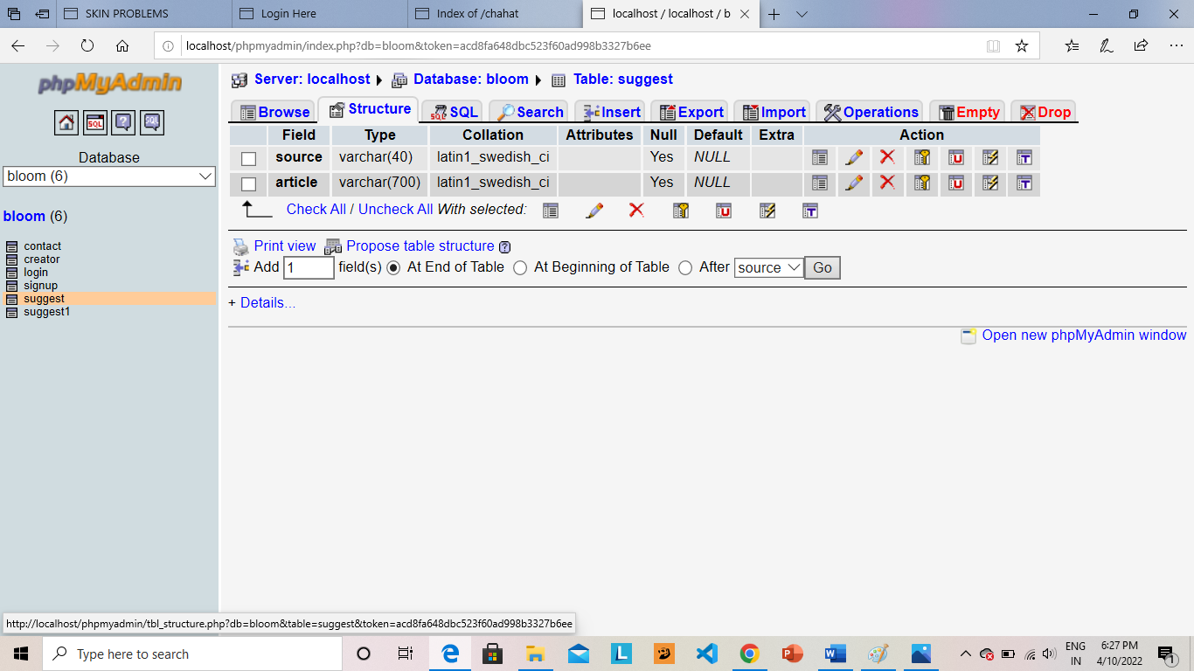

**Browser Of Anything Else**

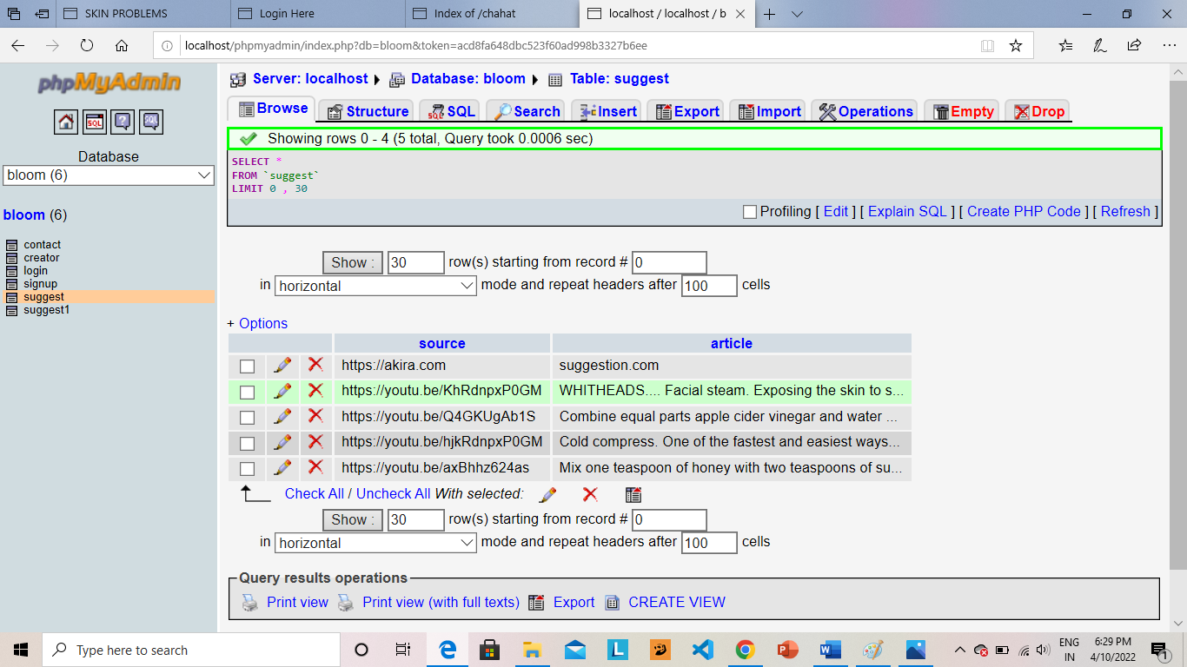

**SQL Of Anything Else**

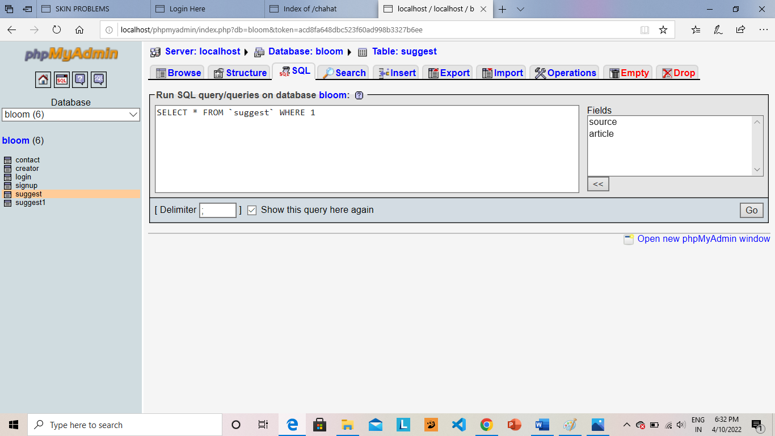

# Conclusion

During working of this project I have a great experience I founf so many logics and learn how to apply them. I found in this project how to divide time and manage the project. I learnt many intresting facts for developing project.It was really wonderful and valuable experience that we got from this project. I created this project and all processes are organized and managed by me.

I learned developing project module and then integrated them. It was really wonderful and learning experience. For the easy management this "**BLOOM SKIN**" has been formed.

# Bibliography

## Refrence:

[www.MySQL.com](http://www.MySQL.com/) [www.MySQLtutorial.org](http://www.MySQLtutorial.org/) [www.tutorialpoint.org](http://www.tutorialpoint.org/) **PHP:**

* PHP was conceived sometime in the fall of 1994 by Rasmus Lerdorf. Early non- released versions were used on his home page to keep track of who was looking at his online resume. The first version used by others was available sometime in early 1995 and was known as the Personal Home Page Tools.
* It is difficult to give any hard statistics, but it is estimated that by late 1996 PHP/FI was in use on at least 15,000 web sites around the world.
* Today (end-1999) either PHP/FI or PHP3 ships with a number of commercial products such as C2's StrongHold web server and RedHat Linux.

## MySQL:

* Codd E. F., "A Relational Model of Data for Large Shared Data Banks",Communications of the ACM, vol. 13, issue 6,pp. 377-387, June 1970.
* Paul DuBois,"MySQL Developer's Library", 4th ed, 2009.
* Russell Dyer,"MySQL in a Nutshell",2nd ed,O'reilly,2008.